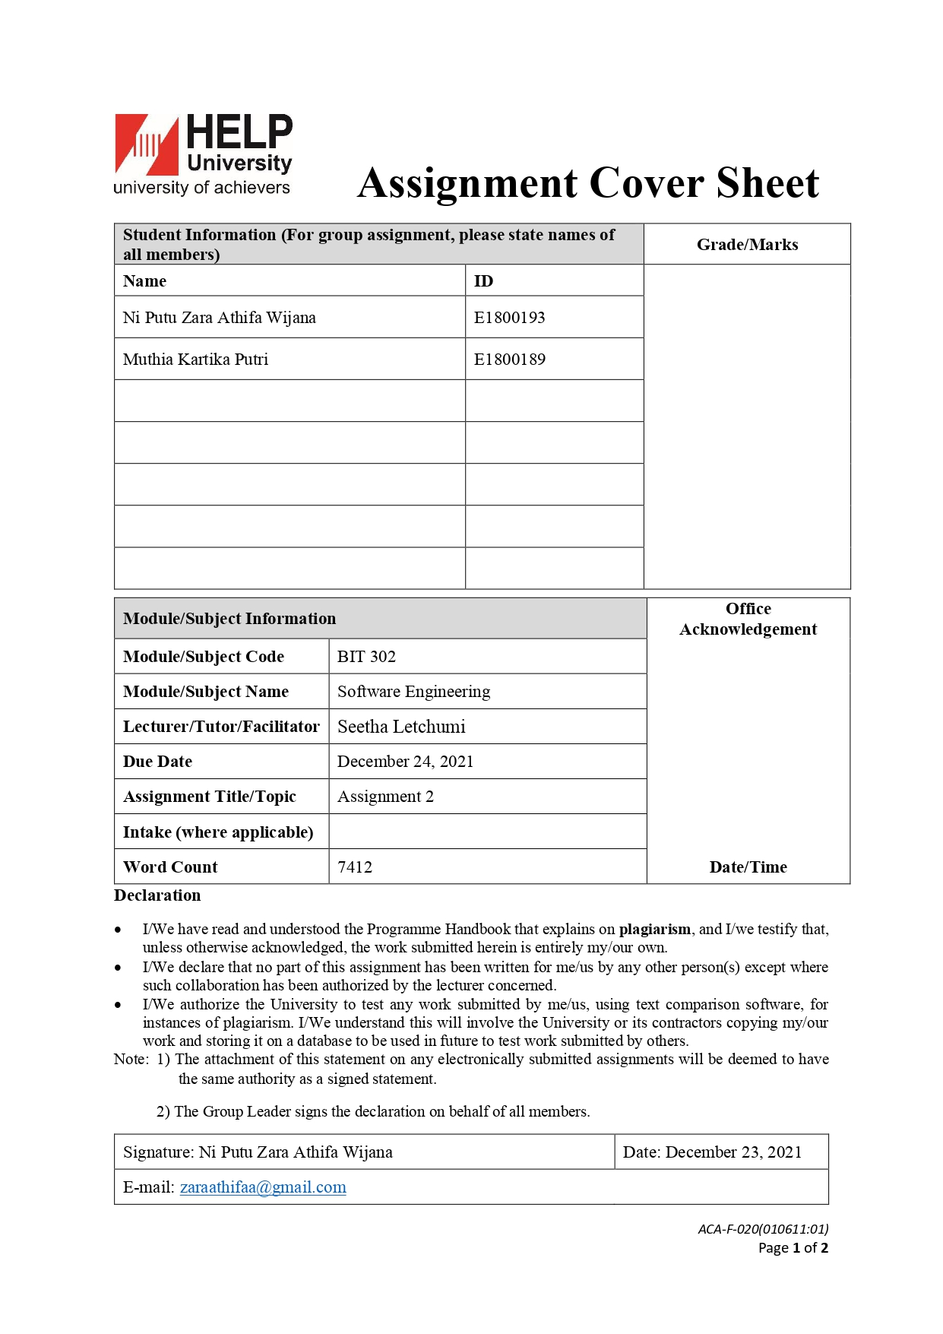

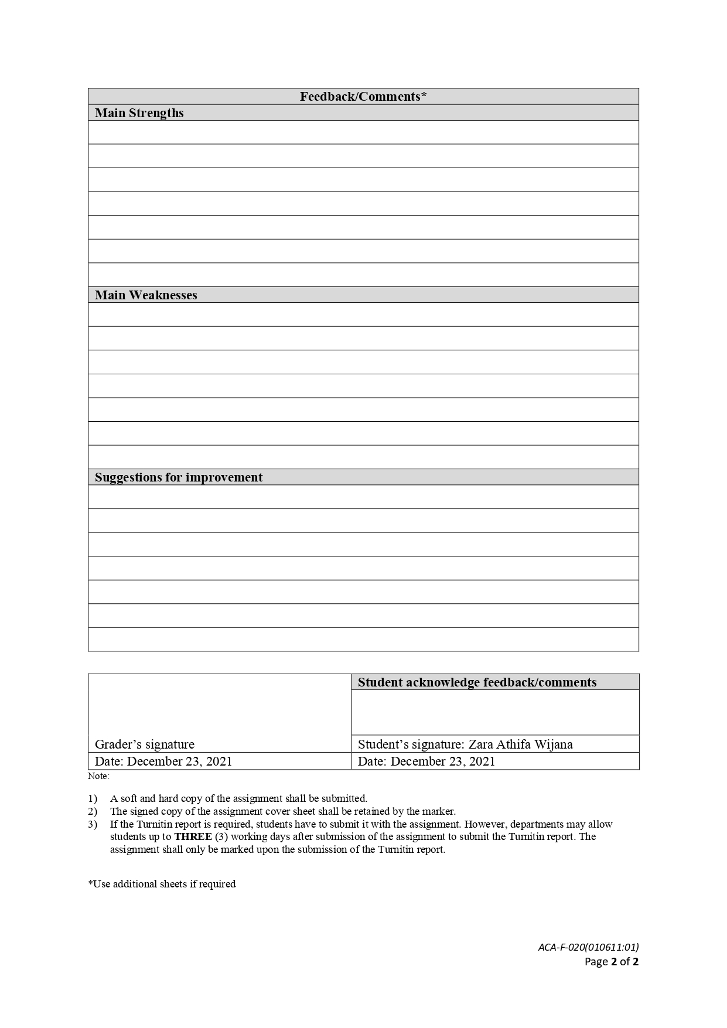

Assignment 3

BIT302

MY Private Vaccine: A Web Based Private Covid-19 Vaccination System

Design and Testing Document of Prototype 2



Ni Putu Zara Athifa Wijana (E1800193)

[zaraathifaa@gmail.com](mailto:zaraathifaa@gmail.com)

as Team Leader

Muthia Kartika Putri (E1800189)

[muthiakartika2@gmail.com](mailto:muthiakartika2@gmail.com)

as Team Member

2021

Table of Contents

I. Follow Up 1

A. Analysis of Design or Documentation Updates 1

1. Use Case Diagram 1

2. Class Diagram 2

3. Expanded Use Case, SSD and Contracts 2

4. Database Dictionary 14

5. ERD 16

6. Wireframe 17

B. Problem Faced in Iteration 1 23

II. Iteration II 23

A. Use Case Identification 23

B. Screenshots 24

C. Test Objectives 35

D. Test Plan 36

E. Test Results 36

1. Unit Testing 36

2. Integration Testing 36

3. System Testing 36

F. Test Analysis Report 49

III. Review 49

A. Gantt Chart Finale 49

B. Git Hub 50

C. Review 52

IV. References 54

# Follow Up

## **Analysis of Design or Documentation Updates**

We will go over some of the modifications that have occurred in previously generated documents in the following sections.

### **Use Case Diagram**

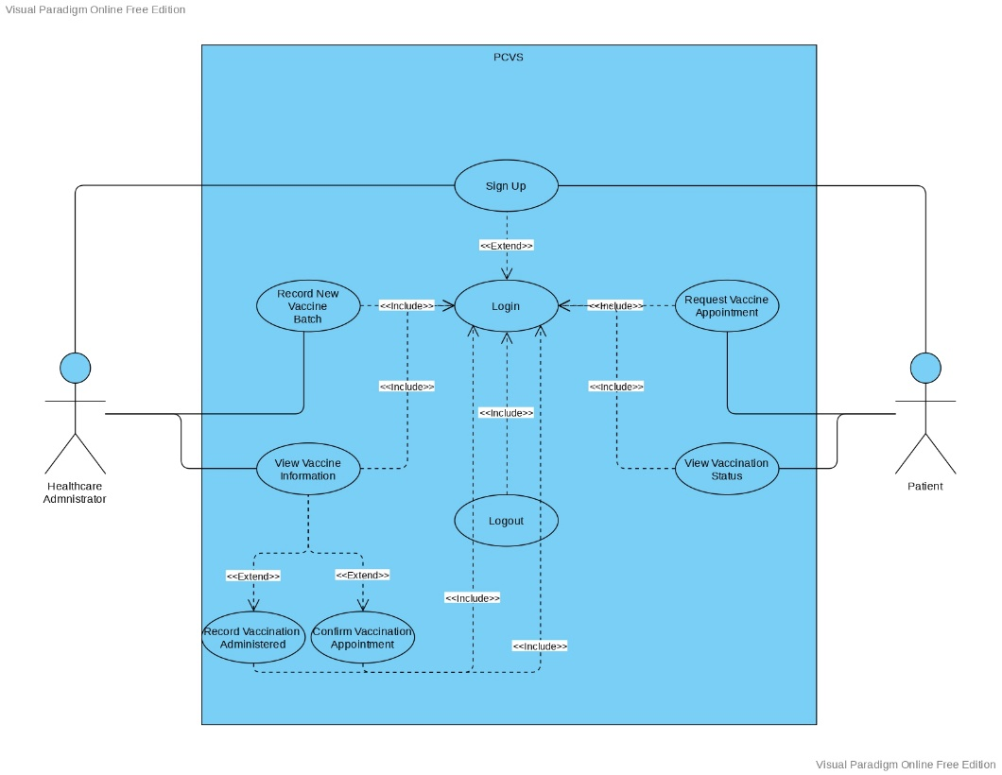

As stated during the presentation for iteration 1, the use case associated to the two prior assignment documents contained a mistake due to human error (task 1 and task 2). In addition, we decided to add one new use case, bringing the total number of use cases from eight to nine. In iteration 1, three use cases were developed, and the other use cases will be developed in iteration 2. The use cases developed for current iteration are Record New Vaccine Batch, View Vaccine Information, Confirm Vaccination Appointment, Record Vaccination Administered, Request Vaccination Appointment, and View Vaccination Status, which is a new use case. The last two use cases stated are for patients, whereas the others are for healthcare administrators.

### **Class Diagram**

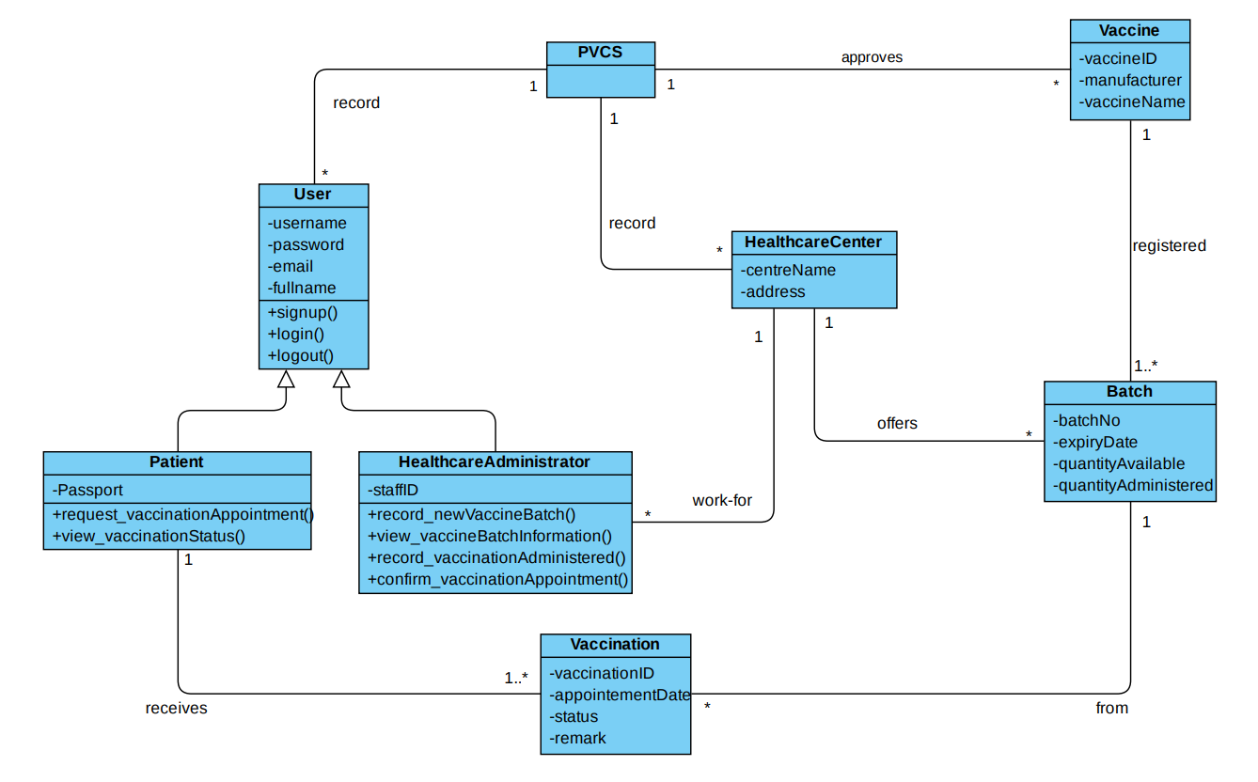

The class diagram has changed slightly as a result of the addition of a new use case for the patient. The class diagram in the image above has been updated. The addition of View Vaccination Status is the change that takes place.

### **Expanded Use Case, SSD and Contracts**

For the use cases we developed in this iteration, additional use cases, and modifications to the use cases from the prior iteration, below we will describe the expanded use case, SSD, and contracts. Please kindly refer to the identifiers in the form of the words:

* Developed: the developed use case for current iteration
* Updated: the updated use case from the previous iteration
* New: the new use case added

inside brackets at the end of the name of the use case that are under discussion.

**Student Name & ID: Ni Putu Zara Athifa Wijana & E1800193**

1. **Sign Up** (updated)

* SSD

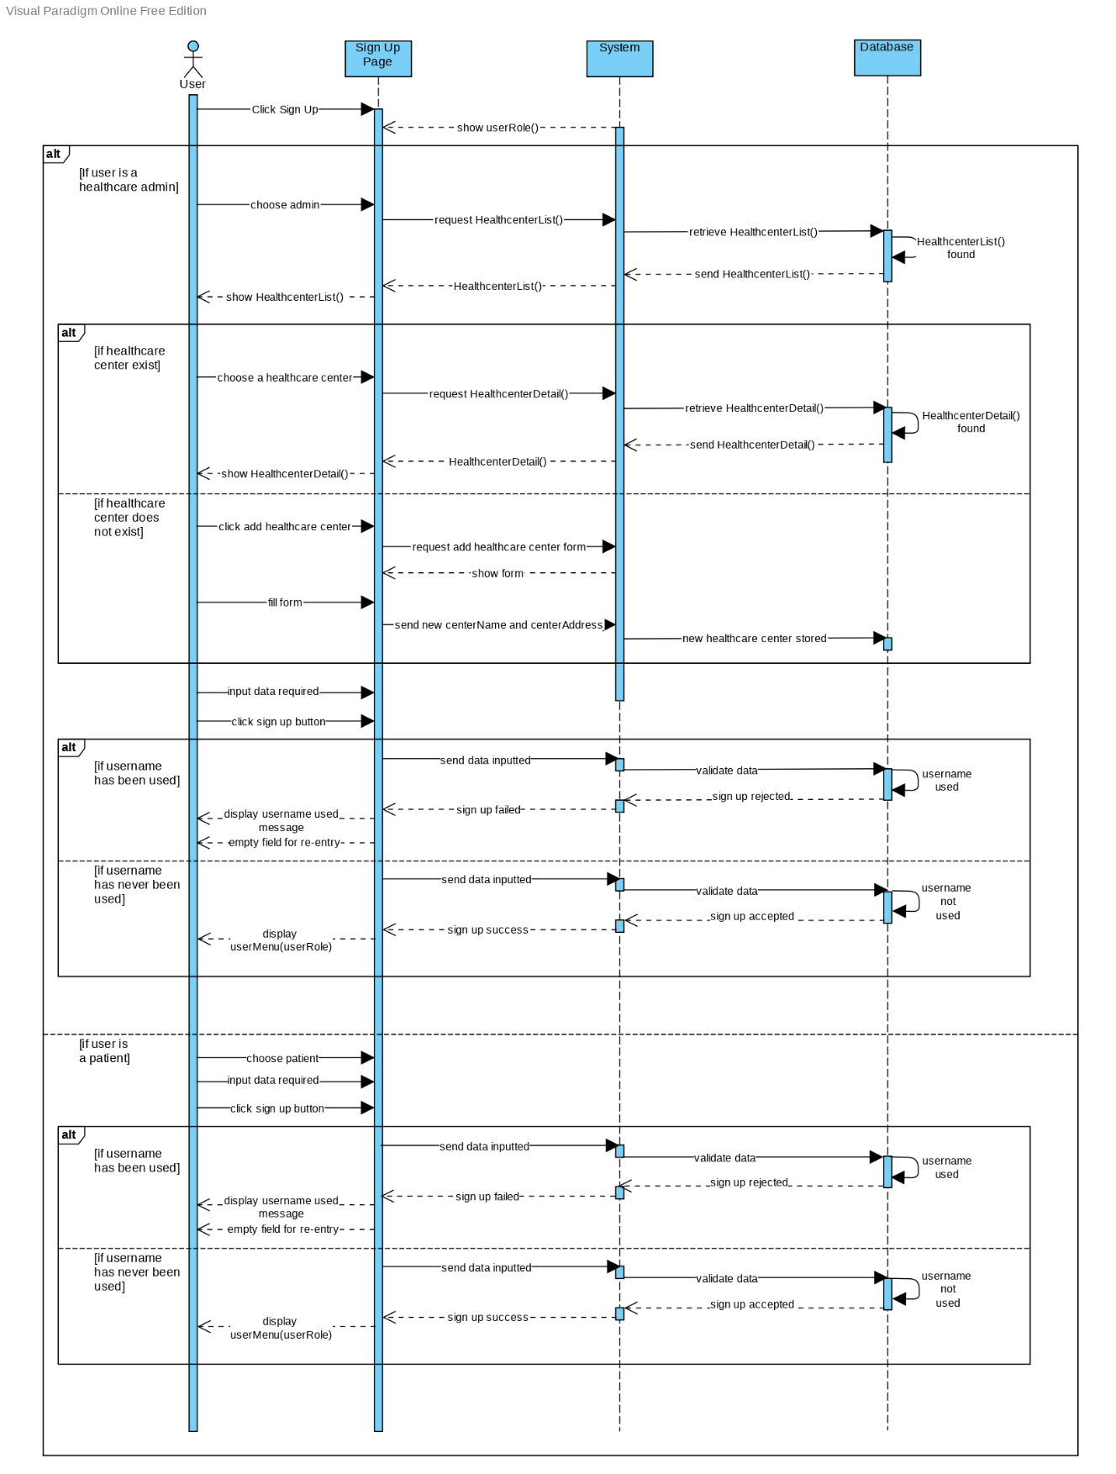

* Contract

|  |  |
| --- | --- |
| **Cross References** | **Sign Up for Patient** |
| Operation | Signup(username, password, email, fullName, ICPassport) |
| Responsible | To allow potential patient to sign up |
| Pre-conditions | * A valid and active email exist * ICPassport registered * Unused username |
| Post-conditions | * Patient account created * Directed to patient menu page   **If** username used  **Then** clear field for re-entry |
| **Cross References** | **Sign Up for Healthcare Administrator** |
| Operation | Signup(username, password, email, fullName, staffID) |
| Responsible | To allow potential healthcare administrator to sign up |
| Pre-conditions | * A valid and active email exist * Registered to a healthcare centre as a staff   **If** a healthcare centre is not listed  **then** add centerName and centerAddress |
| Post-conditions | * Healthcare administrator account created * Staff ID automatically generated * Directed to healthcare administrator menu page   **If** username used  **Then** clear field for re-entry |

1. **Login** (updated)

* Expanded Use Case

|  |  |  |
| --- | --- | --- |
| **Use Case 2** | Login | |
| **Goal** | Allow existing PCVS users (patients and healthcare administrators) to log in. | |
| **Actor** |  | |
| * **Primary** | User (patients and healthcare administrator) | |
| * **Secondary** | - | |
| **Trigger** | A existing user wants to sign in to the PCVS | |
| **Typical Course of Events** | | |
| **Actor Action** | | **System Response** |
| 1. this use case begins when a user (patients or healthcare administrators) wishes to sign in to PCVS. | |  |
| 1. The user (patients and healthcare providers) inputs their login and password. | | According to the user's role, the system will route them to their dashboard. |
| 1. The user (patients and healthcare administrator) enters the username and password | | The system will redirect the user to their dashboard according to their role |
| **Alternative Course of Events** | | |
| 3a: If the username and password does not match, the system will clear field for re-entry | | |

* SSD

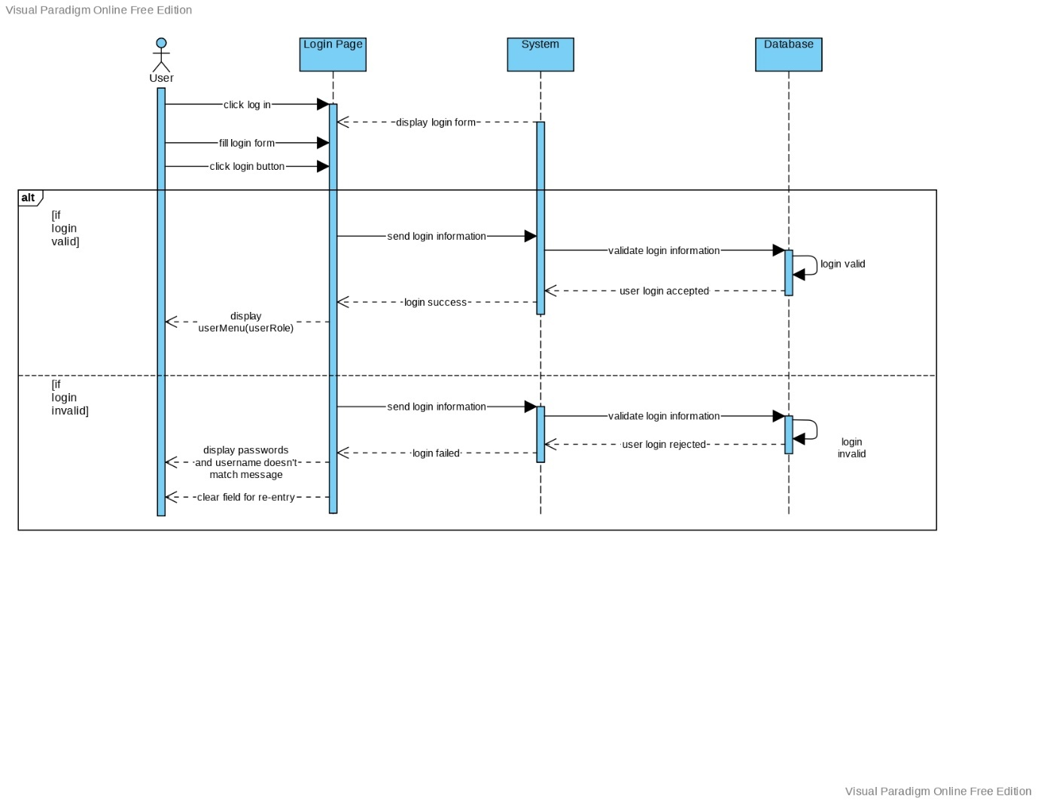

* Contract

|  |  |
| --- | --- |
| **Cross References** | **Login** |
| Operation | Login(username, password) |
| Responsible | allow the user to access menu and feature according to the user's role |
| Pre-conditions | * Username and password should valid |
| Post-conditions | **If** login valid   * Directed to healthcare administrator/patient menu page * Login session started   **Else**   * Clear both field for re-entry * Login session pending |

1. **Record New Vaccine Batch** (developed)

* SSD

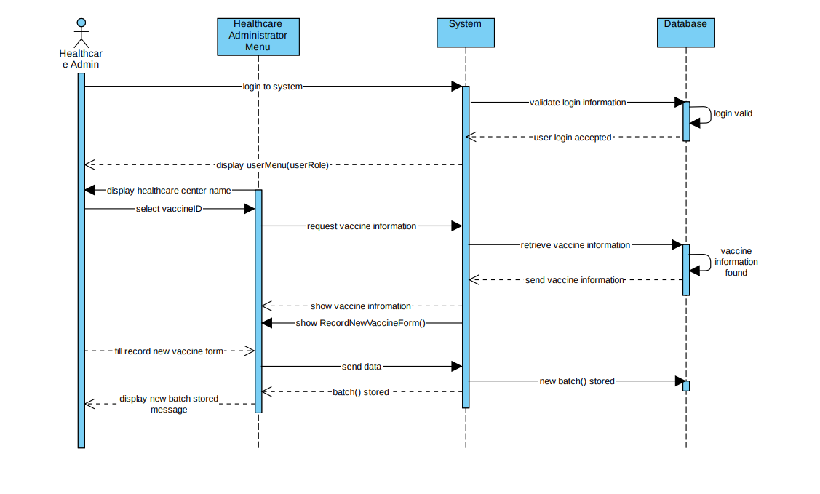

* Contract

|  |  |
| --- | --- |
| **Cross References** | **Record new vaccine batch** |
| Operation | Login(username, password) |
| Responsible | allow healthcare administrator to access menu and feature |
| Pre-conditions | * Username and password should valid |
| Post-conditions | * Directed to healthcare administrator menu page * Login session started |
| **Cross References** | **Record new vaccine batch** |
| Operation | RecordNewVaccineBatch() |
| Responsible | Allow healthcare administrator to record new vaccine batch |
| Pre-conditions | * New vaccine batch number, expiry date and the quantity of doses should available |
| Post-conditions | * New batch of vaccine recorded * Display success message |

1. **Request Vaccination Appointment** (updated & developed)

* SSD

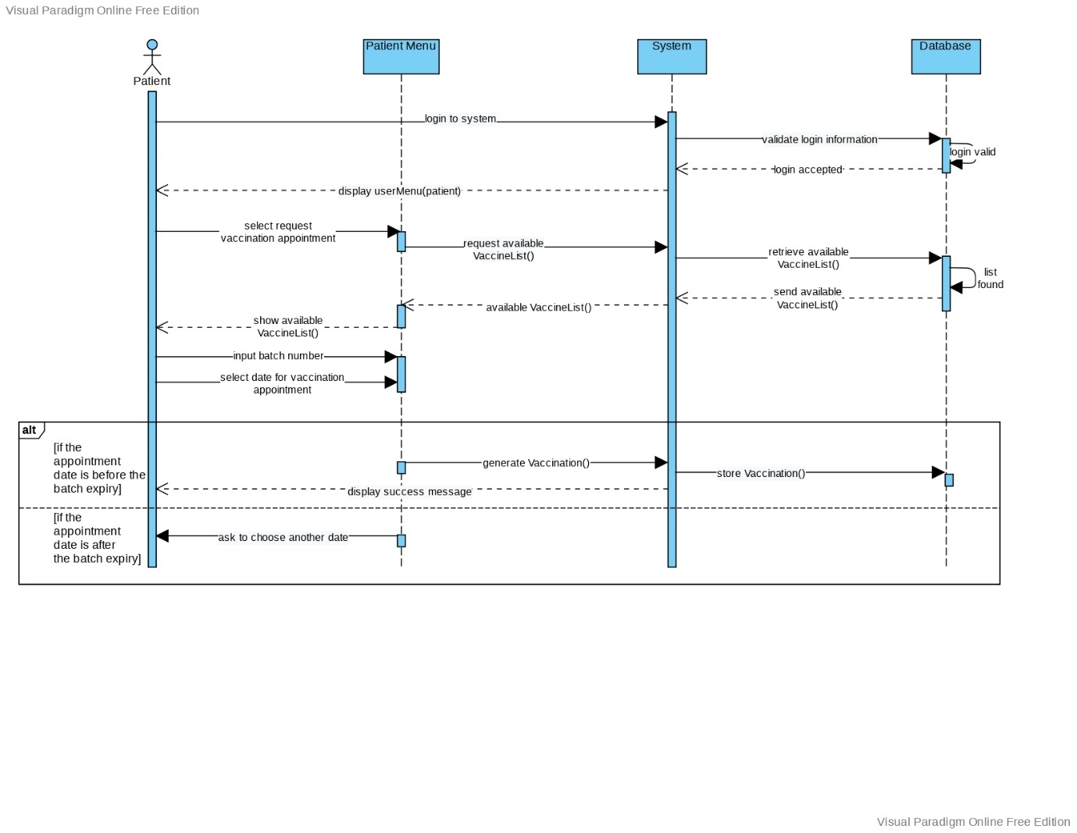

* Contract

|  |  |
| --- | --- |
| **Cross References** | **Request vaccination appointment** |
| Operation | Login(username, password) |
| Responsible | allow patient to access menu and feature |
| Pre-conditions | * Username and password should valid |
| Post-conditions | * Directed to patient menu page * Login session started |
| **Cross References** | **Request vaccine appointment** |
| Operation | RequestVaccinationAppointment() |
| Responsible | allow patient to request vaccination date and healthcare centre |
| Pre-conditions | * Patient fullName displayed * Batch number selected * Date selected   **If** date selected after batch expiry date  **Then** patient select another date |
| Post-conditions | * vaccinationID generated * display success message |

1. **Logout**

* SSD

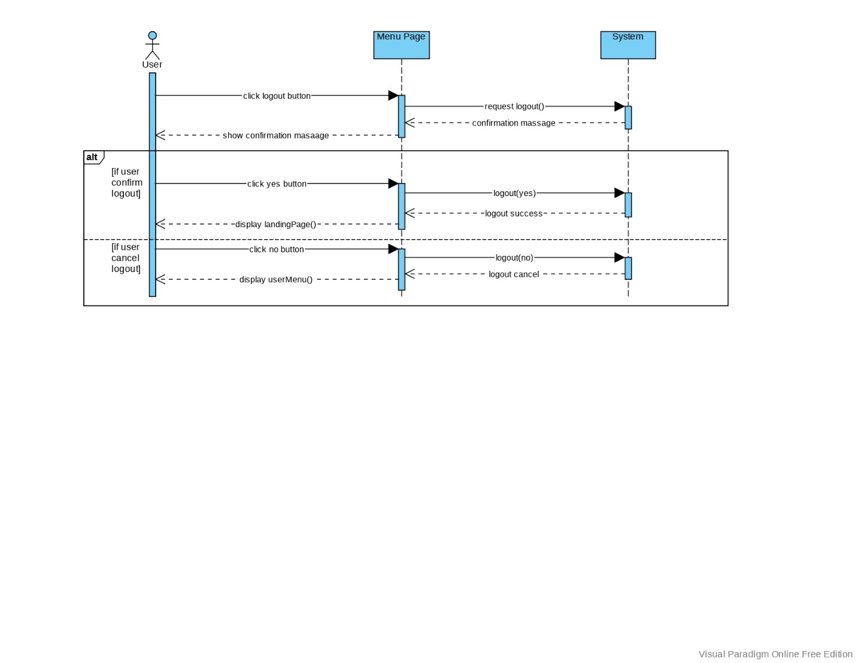

* Contract

|  |  |
| --- | --- |
| **Cross References** | **Logout** |
| Operation | Logout() |
| Responsible | allow the user to logout from the system |
| Pre-conditions | * Session started * Click logout button |
| Post-conditions | **If** logout(yes)   * Click yes on the confirmation message * Login session ended   **else**   * Click no on the confirmation message * Back to user menu |

**Student Name & ID: Muthia Kartika Putri & E1800189**

1. **View Vaccine Batch Information** (developed & updated)

* SSD

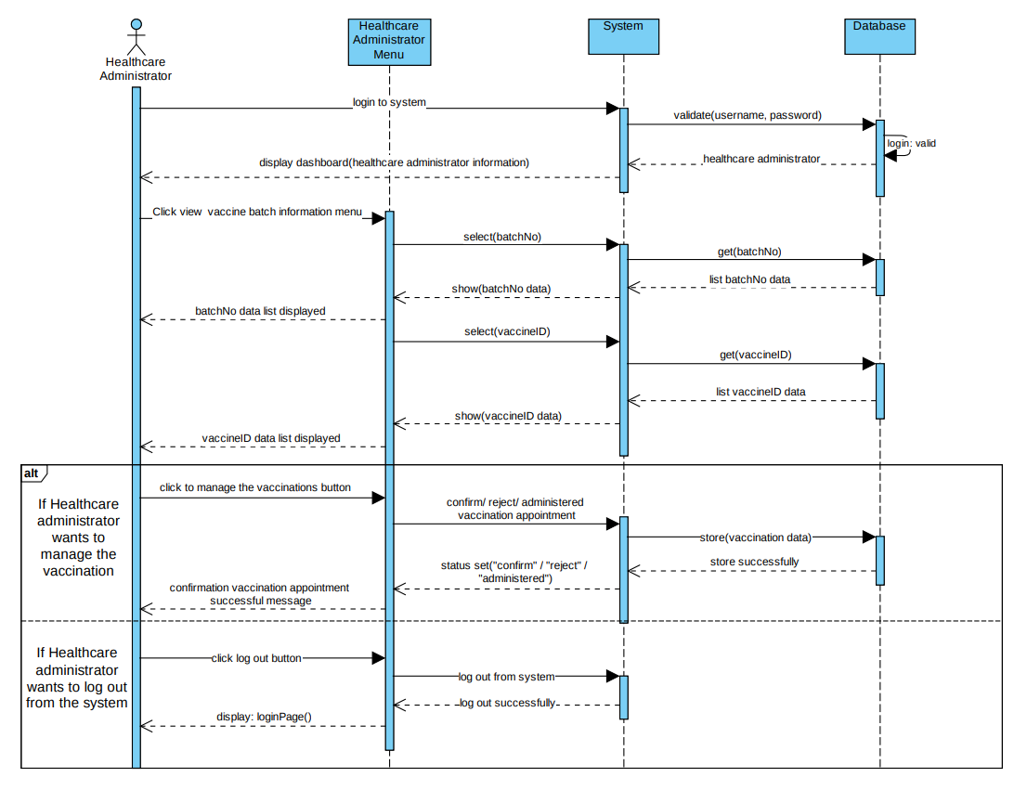

* Contract

|  |  |
| --- | --- |
| **Cross References** | **View Vaccine Batch Information** |
| Operation | Login(username, password) |
| Responsible | To permit the healthcare administrator to access the healthcare administrator’s dashboard. |
| Pre-conditions | * Healthcare administrator object must be available * Username and Password must be available |
| Post-conditions | * Username and Password is matched or valid * Display healthcare administrator dashboard |
| **Cross References** | **View Vaccine Batch Information** |
| Operation | View Vaccine Batch |
| Responsible | To view the vaccine batch information data |
| Pre-conditions | * Healthcare administrator object must be available * Vaccine batch has been successfully created |
| Post-conditions | * Batch vaccine data list has been found * Batch vaccine data list is correlated with view vaccine batch information menu (association formation) |
| **Cross References** | **View Vaccine Batch Information** |
| Operation | Manage vaccination appointment |
| Responsible | To manage vaccination appointment |
| Pre-conditions | * Healthcare administrator object must be available * Vaccination appointment data must be available |
| Post-conditions | * Vaccination appointment status is set to “confirm” or “reject” or “administered” * Sending confirm or reject notification message if the status are confirm or reject * Display successful notification |
| **Cross References** | **View Vaccine Batch Information** |
| Operation | Logout from system |
| Responsible | To logout or exit from the system |
| Pre-conditions | * Healthcare administrator object must be available * Confirm to cancel logout |
| Post-conditions | * Redirect to login page |

1. **Confirm Vaccination Appointment** (developed)

* SSD

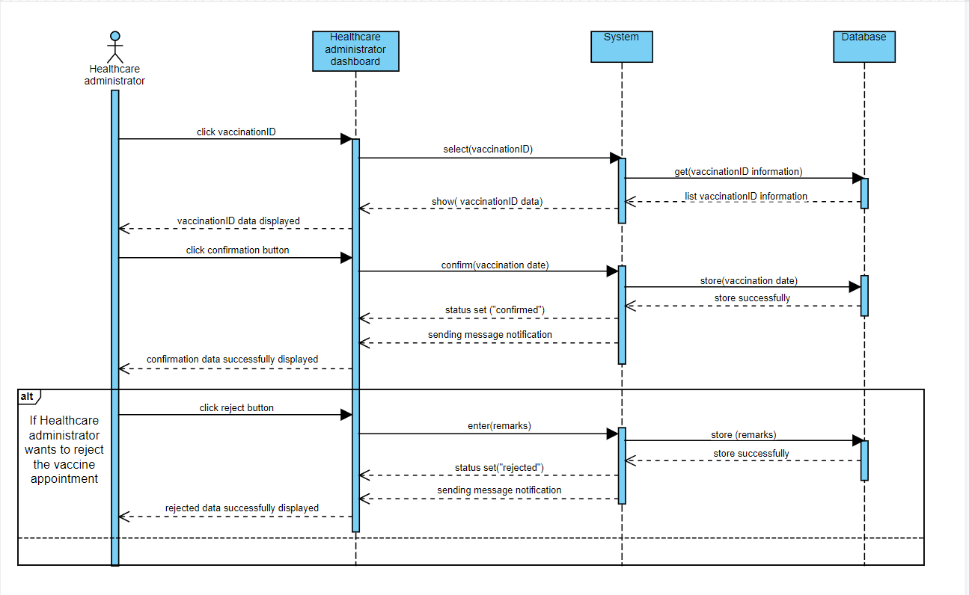

* Contract

|  |  |
| --- | --- |
| **Cross References** | **Confirm Vaccination Appointment** |
| Operation | Confirm vaccination |
| Responsible | To permit the healthcare administrator to confirm the vaccination appointment |
| Pre-conditions | * Healthcare administrator object must be available * vaccinationID must be available |
| Post-conditions | * New status set to “confirm” * Sending a confirmation message * Display confirmation successful notification message   **IF** Healthcare administrator reject the appointment   * New status set to “rejected” * Sending rejected message * Display rejected notification message |

1. **Record Vaccination Administered** (developed)

* SSD

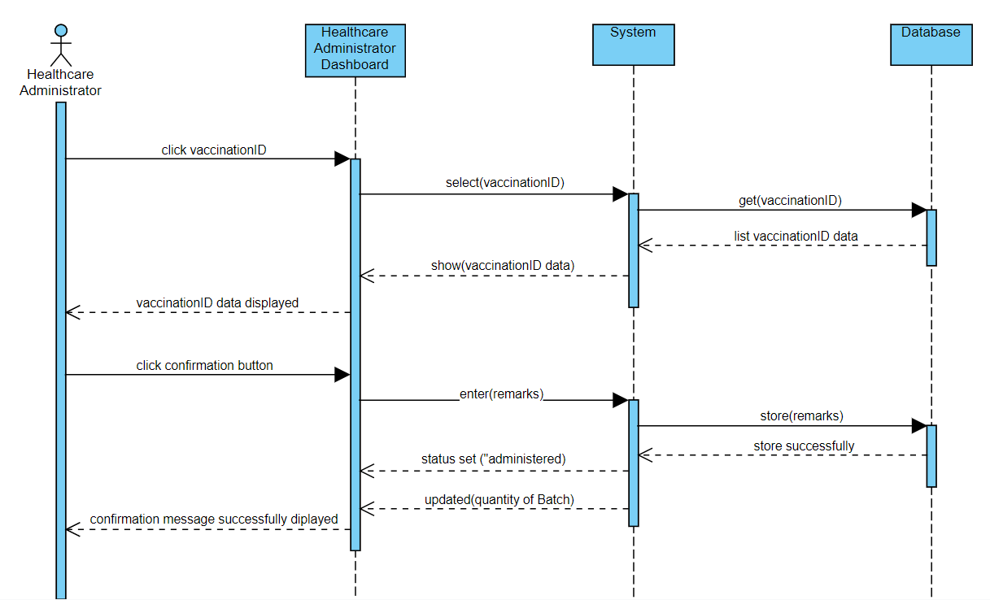

* Contract

|  |  |
| --- | --- |
| **Cross References** | **Record Vaccination Administered** |
| Operation | Record vaccination |
| Responsible | To record the vaccination that has been administered. |
| Pre-conditions | * Healthcare administrator object must be available * vaccinationID must be available |
| Post-conditions | * New status set to “administered” * New remarks entered * Updating the quantity of Batch * Display confirmation successful message |

1. **View Vaccination Status** (new & developed)

* Expanded Use Case

|  |  |  |
| --- | --- | --- |
| **Use Case 9** | View Vaccination Status | |
| **Goal** | To allow a patient to check his vaccination appointment status. | |
| **Actor** |  | |
| **Primary** | Patient | |
| **Secondary** | - | |
| **Trigger** | A patient wants to view his/her vaccination appointment status. | |
| **Typical Course of Events** | | |
| **Actor Action** | | **System Response** |
| 1. This use case begins when a Patient wants to check the status of his or her vaccination appointment | |  |
| 1. The patient logs in by entering a username and password | | The patient’s full name is shown. |
| 1. The patient selects to view status of available vaccination appointment. | | The status of the vaccination appointment is shown. |
| **Alternative Course of Events** | | |
| 3a: If there is no available vaccination appointment, an error message is displayed | | |

* SSD

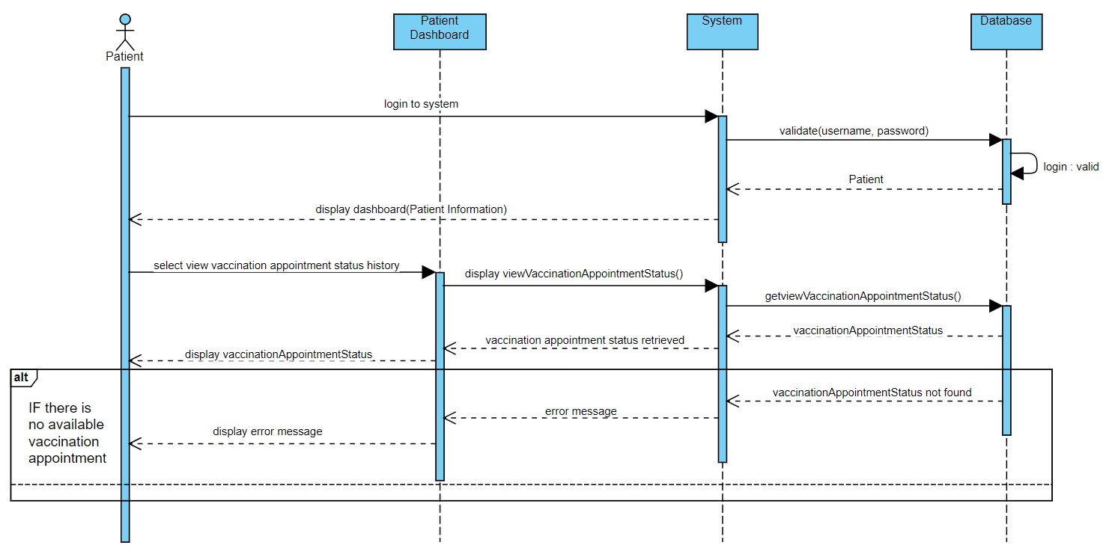

* Contract

|  |  |
| --- | --- |
| **Cross References** | **View Vaccination Status** |
| Operation | Login(username, password) |
| Responsible | To permit the patient to access the patient’s dashboard. |
| Pre-conditions | * Patient object must be available * Username and Password must be available |
| Post-conditions | * Username and Password is matched or valid * Display patient dashboard |
| **Cross References** | **View Vaccination Status** |
| Operation | View Vaccination Status |
| Responsible | To view the vaccine appointment status history |
| Pre-conditions | * Patient object must be available |
| Post-conditions | * Vaccine appointment status has been found * Vaccination appointment status data list is correlated with view vaccination appointment status menu (association formation) * Display vaccination appointment status   **If** vaccination appointment status is unavailable   * Vaccine appointment status not found * Display error message |

### **Database Dictionary**

There are slight modifications to the database dictionary, which is adding a new field in database called ‘other’ as a trigger to add new healthcare center; we incorporate the other database dictionary that was previously provided in the submitted documents as references.

1. User Table

|  |  |  |  |  |
| --- | --- | --- | --- | --- |
| Field Name | Data Type | Field | Description | Example |
| Id | Int | 5 | Administartor ID | 1 |
| icpassport | Varchar | 15 | Patient ICPassport | JPY5171014 |
| centreName | Varchar | 30 | Centre name of healthcare centre | MSU Medical Centre |
| username | Varchar | 15 | Username of user | uzumaki |
| password | Varchar | 15 | Password of user | naruto123 |
| email | Varchar | 30 | Email of user | [narutouzumaki@gmail.com](mailto:narutouzumaki@gmail.com) |
| fullname | Varchar | 30 | Fullname of user | Naruto Uzumaki |
| role | enum |  | Role of user | Administrator |

1. Healthcare Center Table

|  |  |  |  |  |
| --- | --- | --- | --- | --- |
| Field Name | Data Type | Field | Description | Example |
| id | Int | 11 | Healthcare center ID | 1 |
| centreName | Varchar | 30 | Centre name of healthcare center | MSU Medical Centre |
| address | Varchar | 30 | Address of healthcare center | Kuala Lumpur |
| other | Varchar | 15 | Trigger for adding new healthcare center | - |

1. Vaccine Table

|  |  |  |  |  |
| --- | --- | --- | --- | --- |
| Field Name | Data Type | Field | Description | Example |
| vaccineId | Int | 5 | Vaccine ID | 1 |
| manufacturer | Varchar | 15 | Manufacturer of vaccine | Coronavac |
| vaccine_name | Varchar | 15 | Name of vaccine | Sinovac |

1. Batch Table

|  |  |  |  |  |
| --- | --- | --- | --- | --- |
| Field Name | Data Type | Field | Description | Example |
| batchNo | Varchar | 15 | Batch number of vaccine | 87Y679 |
| expiryDate | date |  | Expiry date of batch | 12/12/2021 |
| quantityAvailable | Int | 5 | Quantity available of batch | 100 |
| quantityAdministered | Int | 5 | Quantity administered of batch | 50 |
| vaccineID | Int | 11 | Vaccine ID | 1 |
| centreName | Varchar | 30 | Centre name of healthcare centre | MSU Medical Centre |

1. Vaccination Table

|  |  |  |  |  |
| --- | --- | --- | --- | --- |
| Field Name | Data Type | Field | Description | Example |
| vaccinationId | Int | 5 | Vaccination id | 1 |
| batchNo | Varchar | 15 | Batch number of vaccine | 87Y679 |
| appointmentDate | date |  | Appointment date of vaccination | 12/12/2021 |
| status | Varchar | 15 | Status of vaccination | Pending |
| remarks | Varchar | 50 | Remark of vaccination | This vaccine has not been accepted yet |
| fullname | Varchar | 30 | Full name of user | Naruto Uzumaki |

### **ERD**

The ERD has not been altered; but, we have included the ERD that was previously provided in the submitted documents as a reference.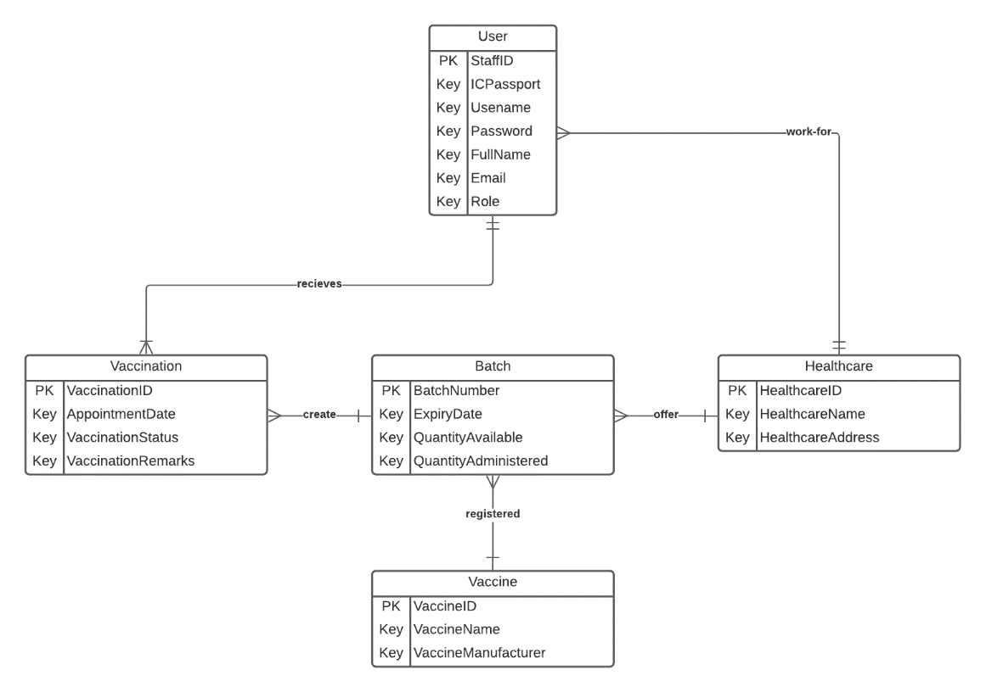

### **Wireframe**

Due to the addition of one use case and updating the sign up use case, we also add one image for the view vaccination status wireframe and two image for the sign up use case, other than that the wireframe stays the same. We have included the wireframe that was originally supplied in the submitted materials as a reference.

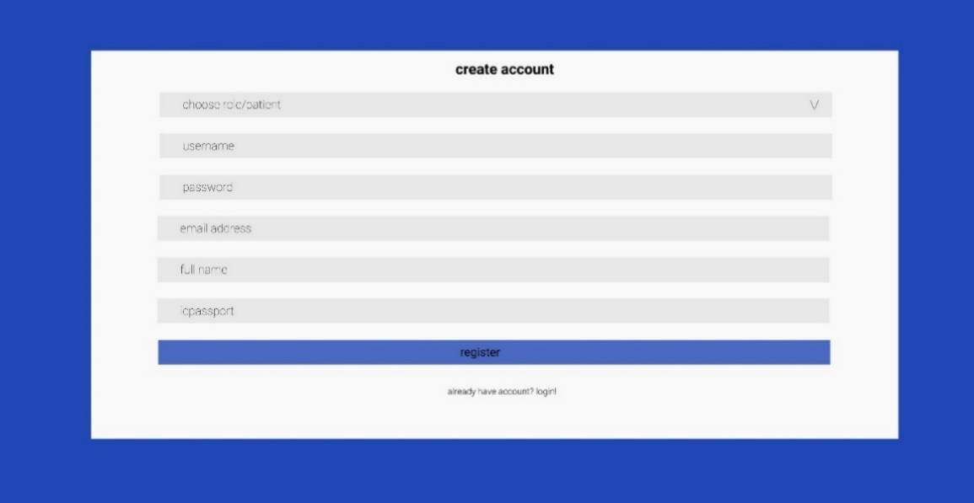

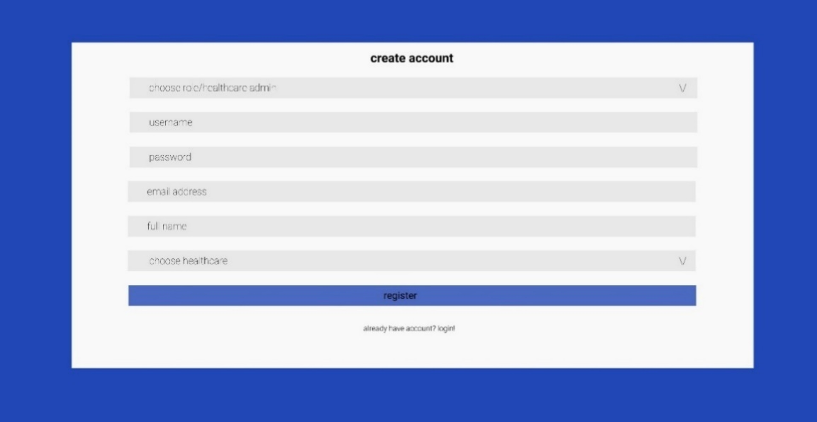

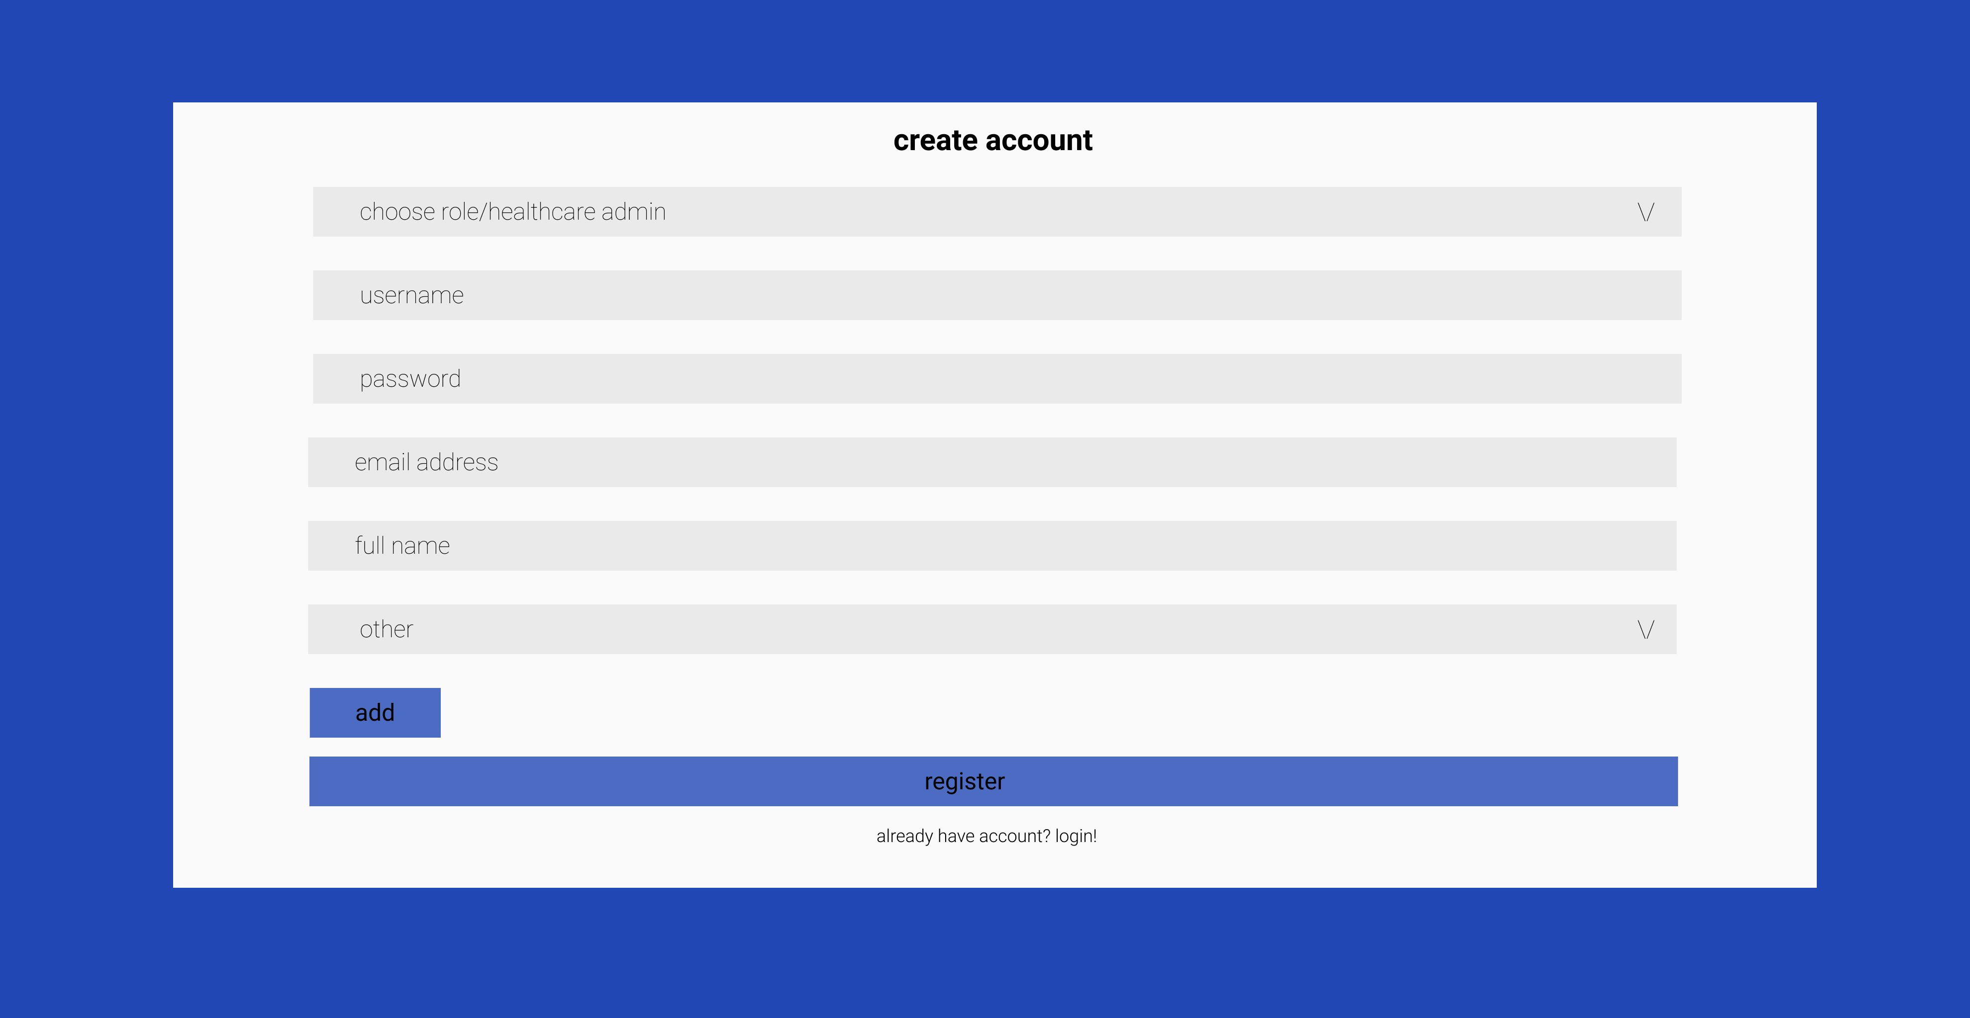

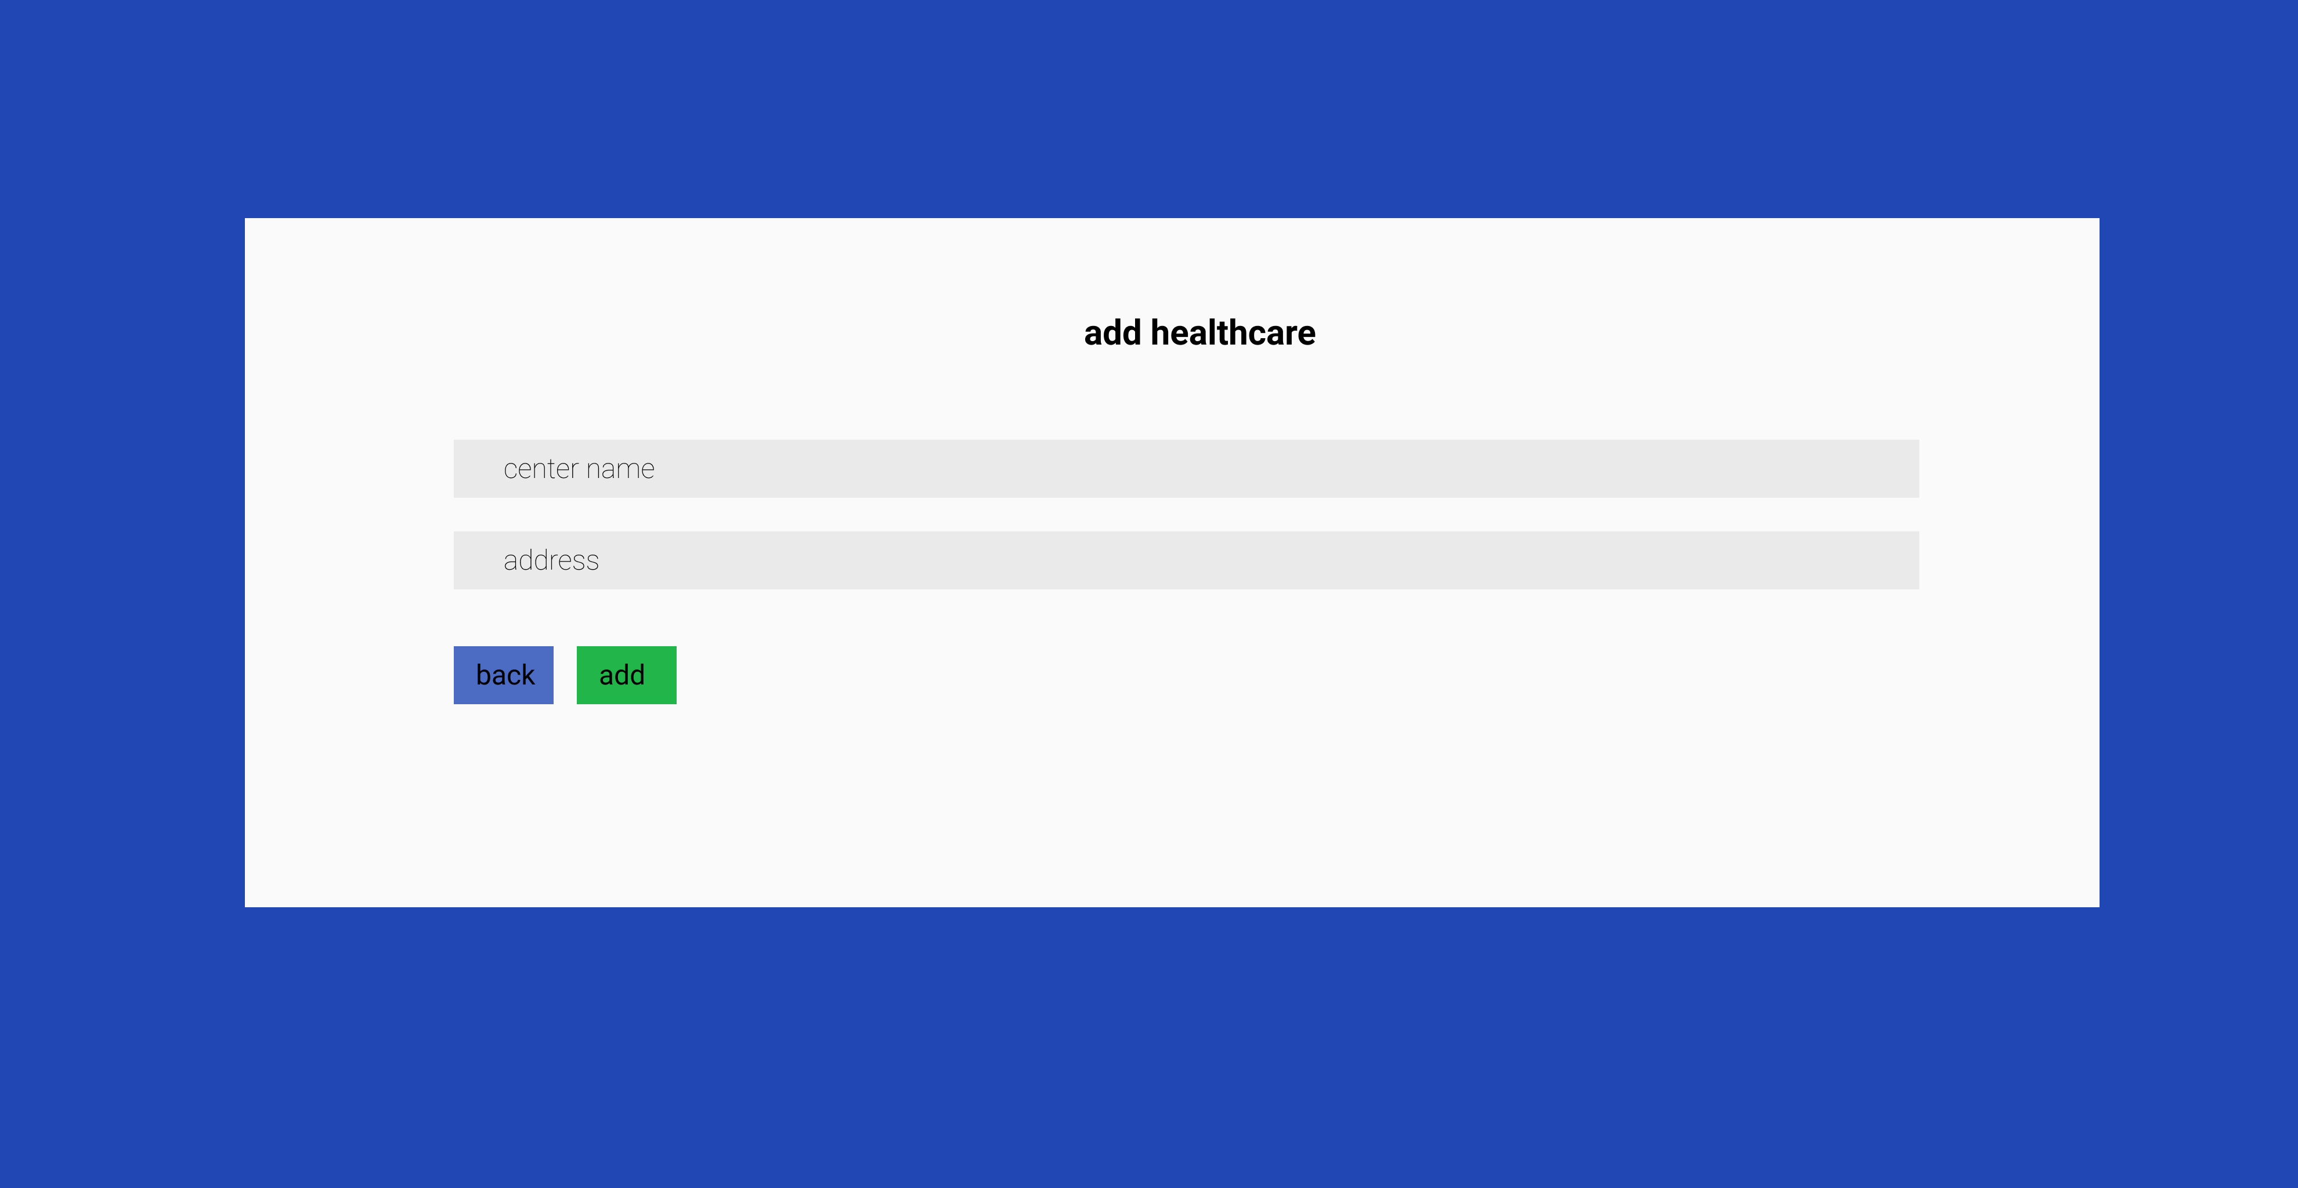

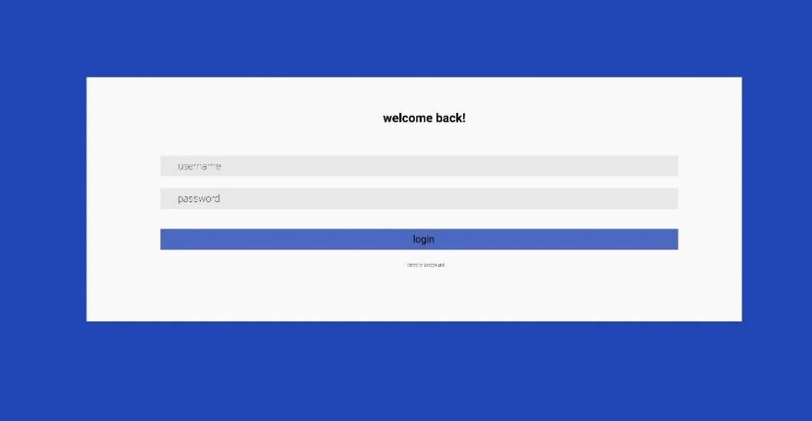

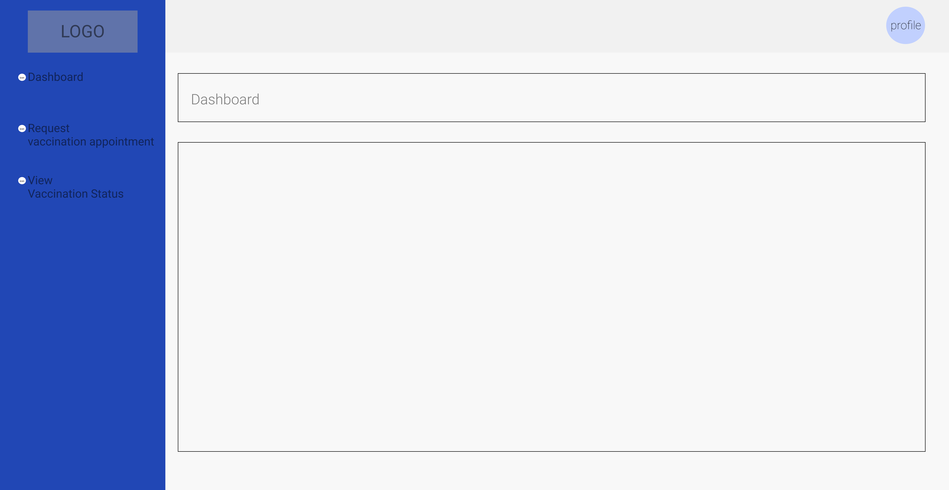

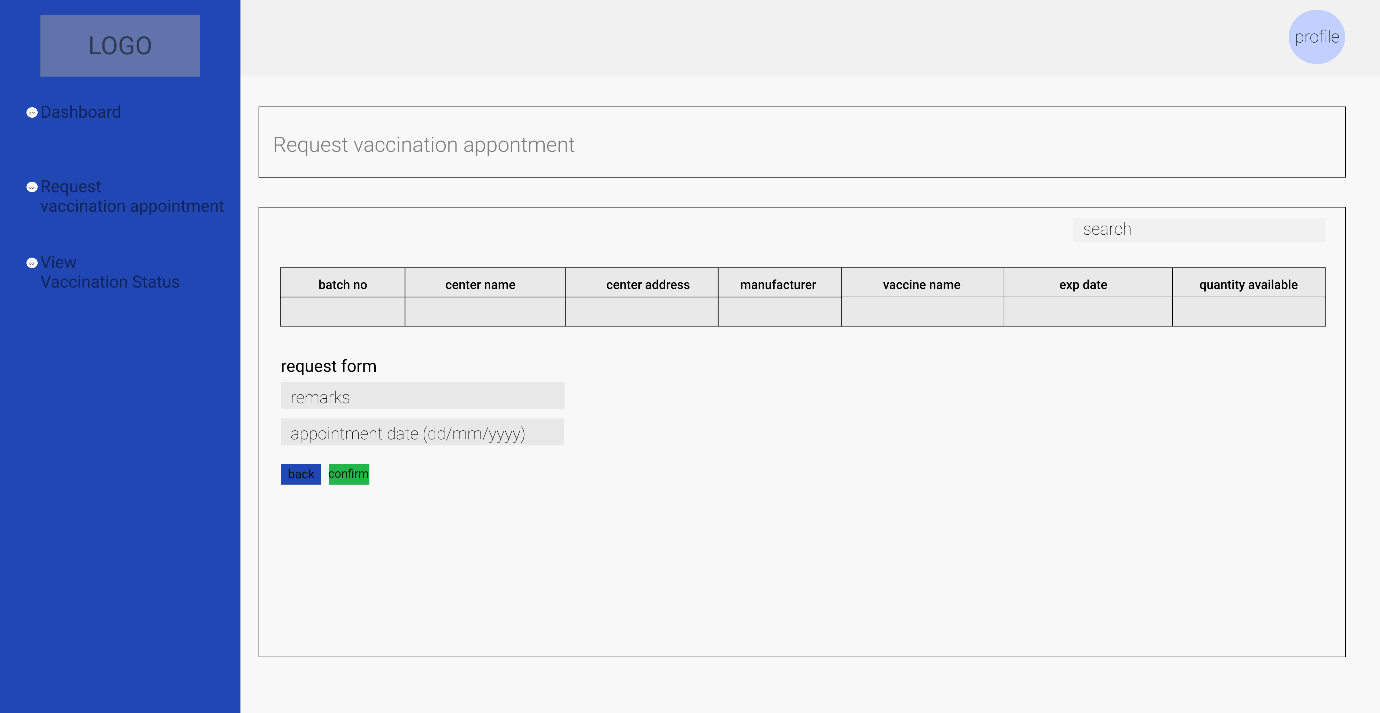

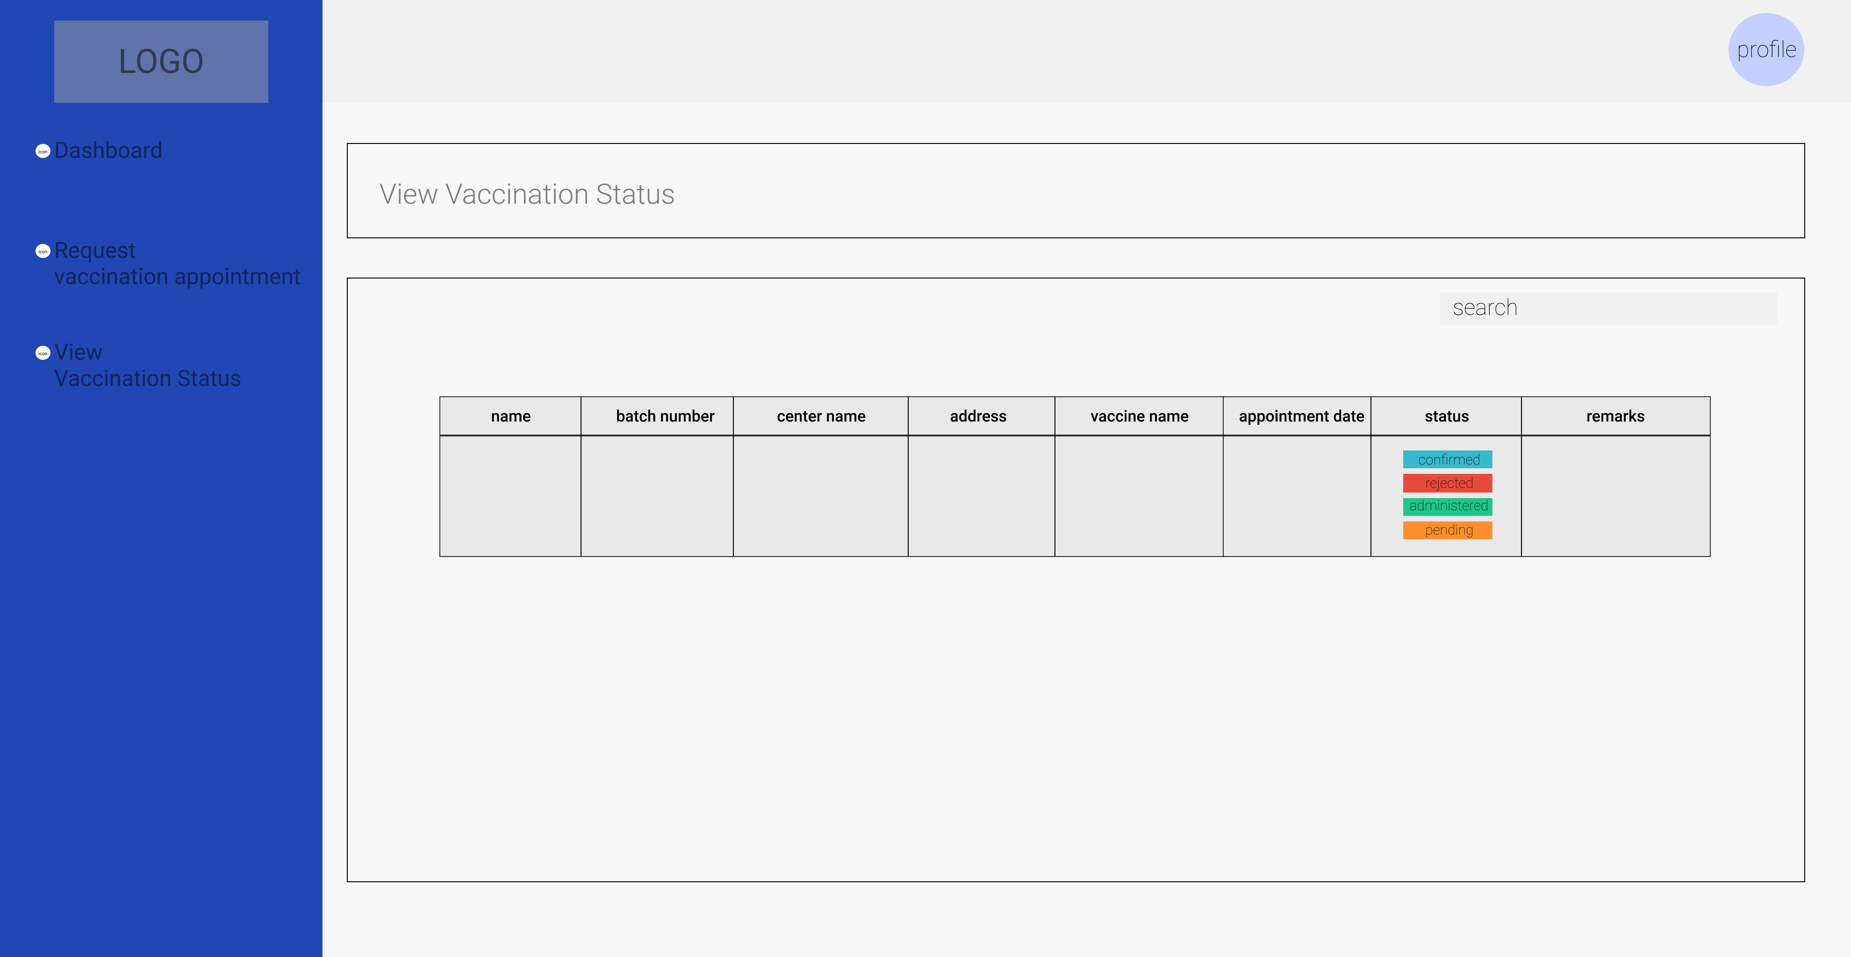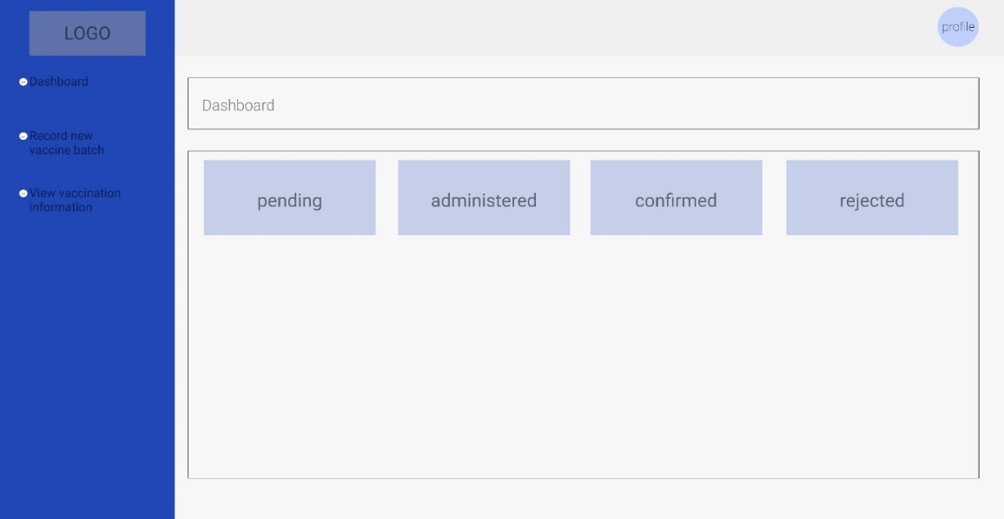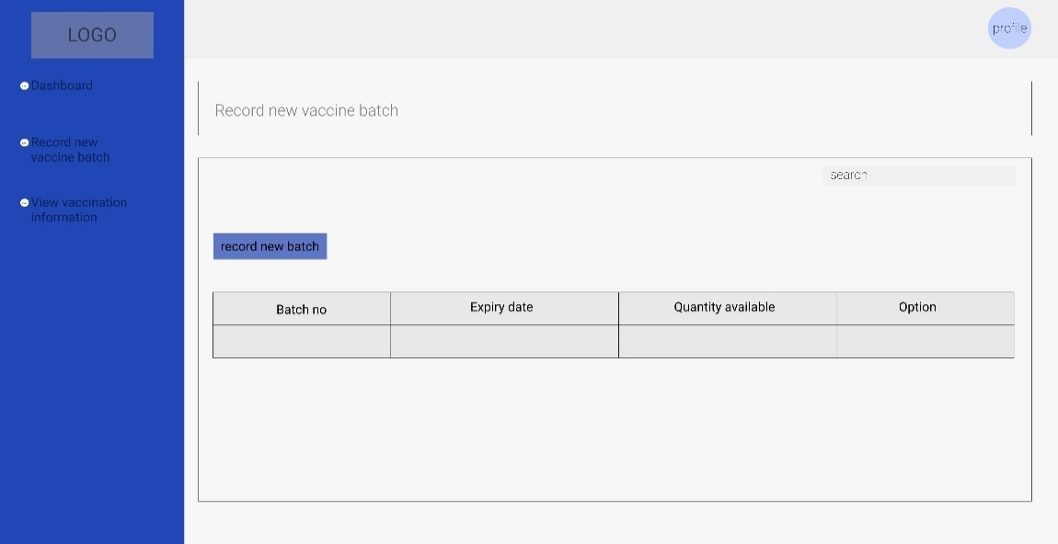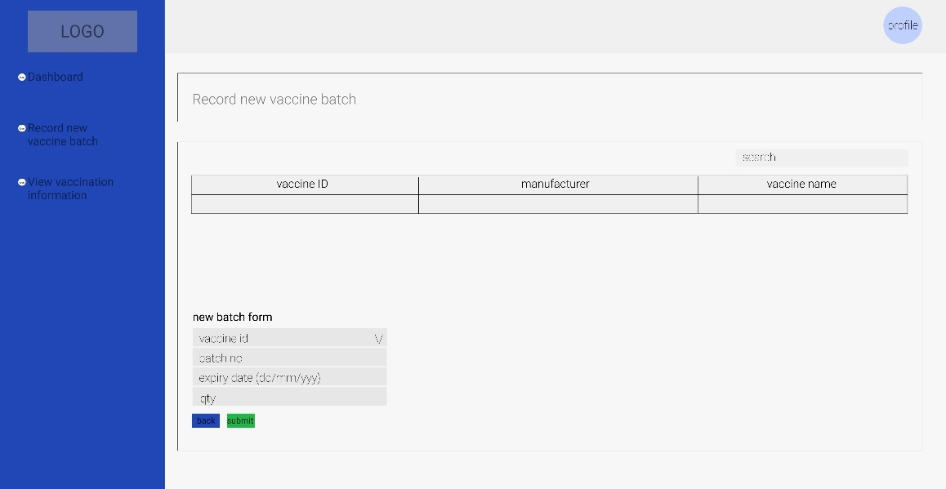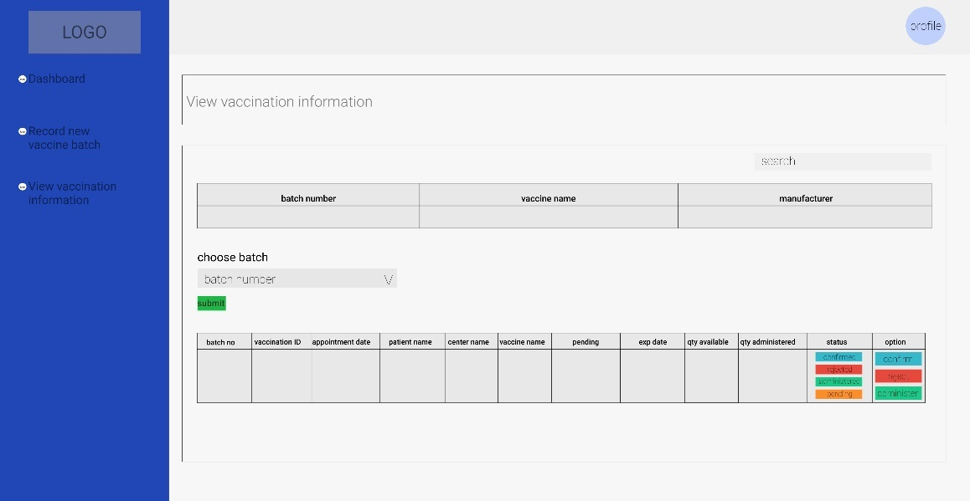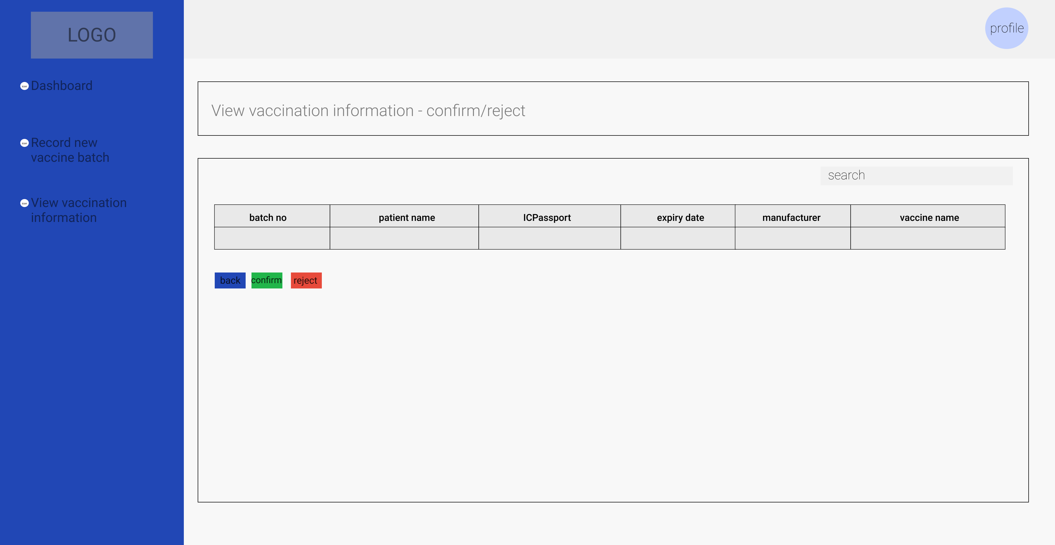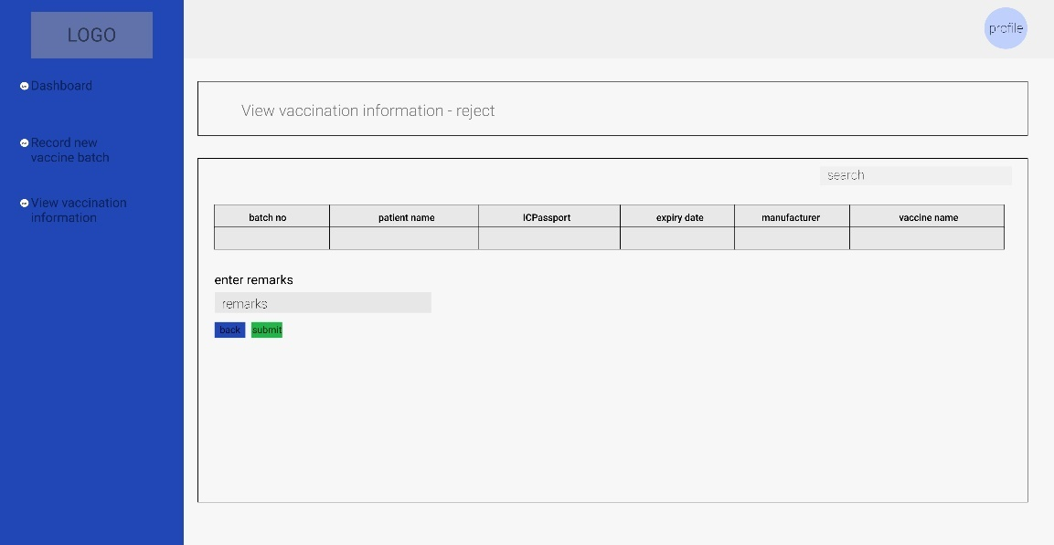

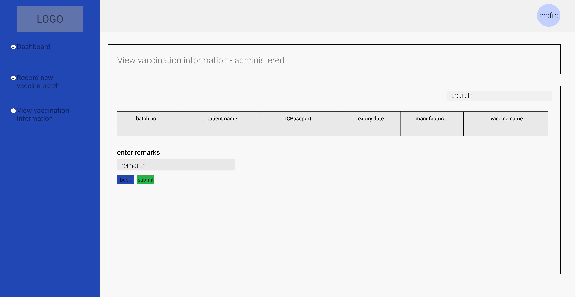

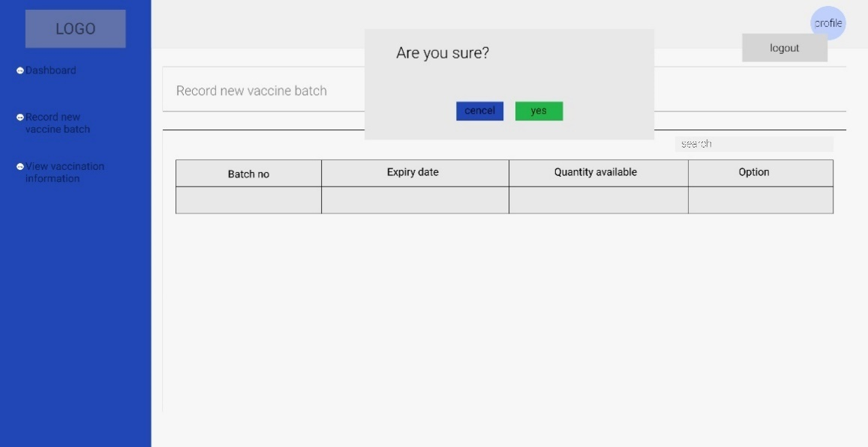

## **Problem Faced in Iteration 1**

We did not encounter or face any severe issues in iteration one development. The biggest issue we have is time management because we have various other activities and jobs to complete; nevertheless, we do not have any other issues such as teamwork, communication, or other issues that we are unable to resolve and have serious damage to the project.

# Iteration II

## **Use Case Identification**

We already developed three use cases for the previous, all of which are the responsibility of Ni Putu Zara Athifa Wijana. The remaining 6 use cases were developed in this document; the majority of the use cases for this iteration were developed by Muthia Kartika Putri; for additional information, please refer to the table below.

* Iteration 1

|  |  |  |
| --- | --- | --- |
| No. | Use Case | Develop by |
| 1. | Sign Up | Ni Putu Zara Athifa Wijana |
| 2. | Login | Ni Putu Zara Athifa Wijana |
| 3. | Logout | Ni Putu Zara Athifa Wijana |

* Iteration 2

|  |  |  |
| --- | --- | --- |
| No. | Use Case | Develop by |
| 1. | Request vaccine appointment | Ni Putu Zara Athifa Wijana |
| 2. | Record new vaccine batch | Ni Putu Zara Athifa Wijana |
| 3. | View vaccine information | Muthia Kartika Putri |
| 4. | Record vaccination administered | Muthia Kartika Putri |
| 5. | Confirm vaccination appointment | Muthia Kartika Putri |
| 6. | View vaccination status | Muthia Kartika Putri |

## **Screenshots**

Hereby we show screenshots of our website’s sample of various cases

1. **Sign Up/Registration**

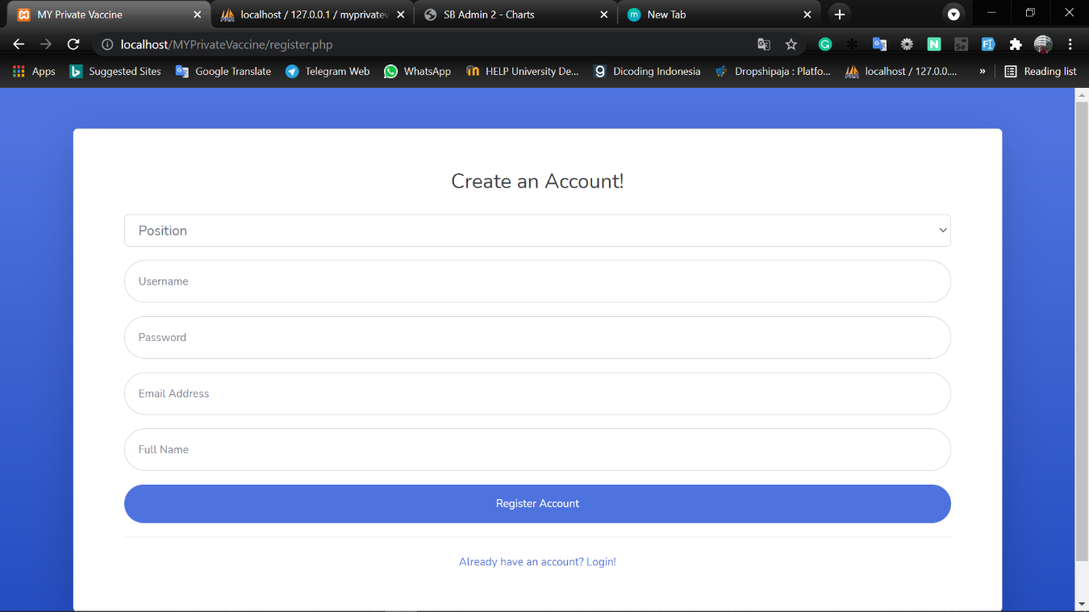

* If user is a patient

User then choose role, if user is a patient, the ICPassport field shown

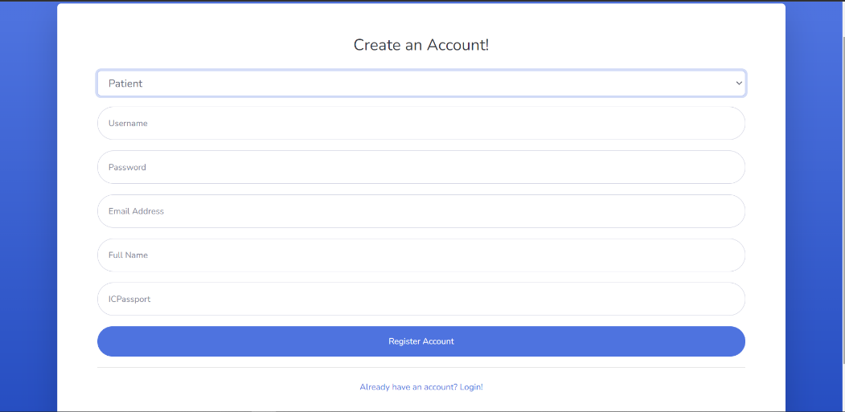

* If user is a healthcare administrator

User then choose role, if user is a healthcare admin, the center name field shown, admin then choose a healthcare to assign

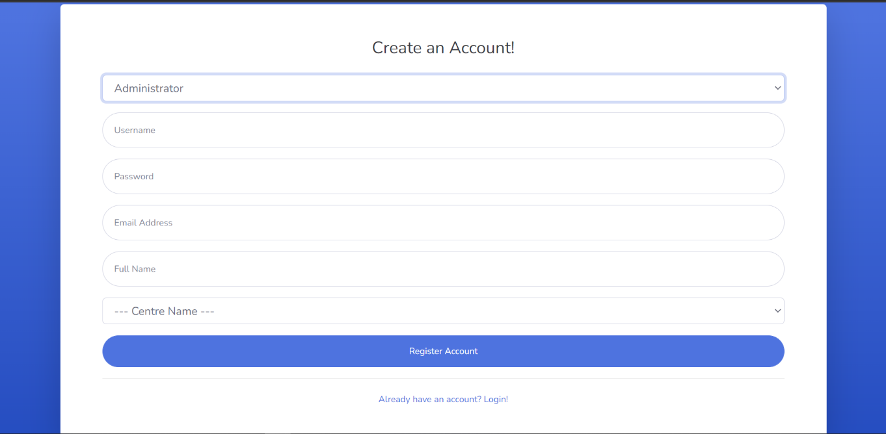

When healthcare admin choose to add healthcare center

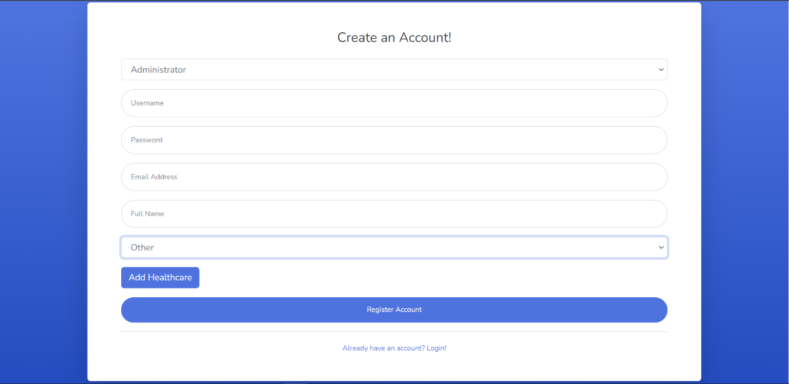

Healthcare administrator click add button

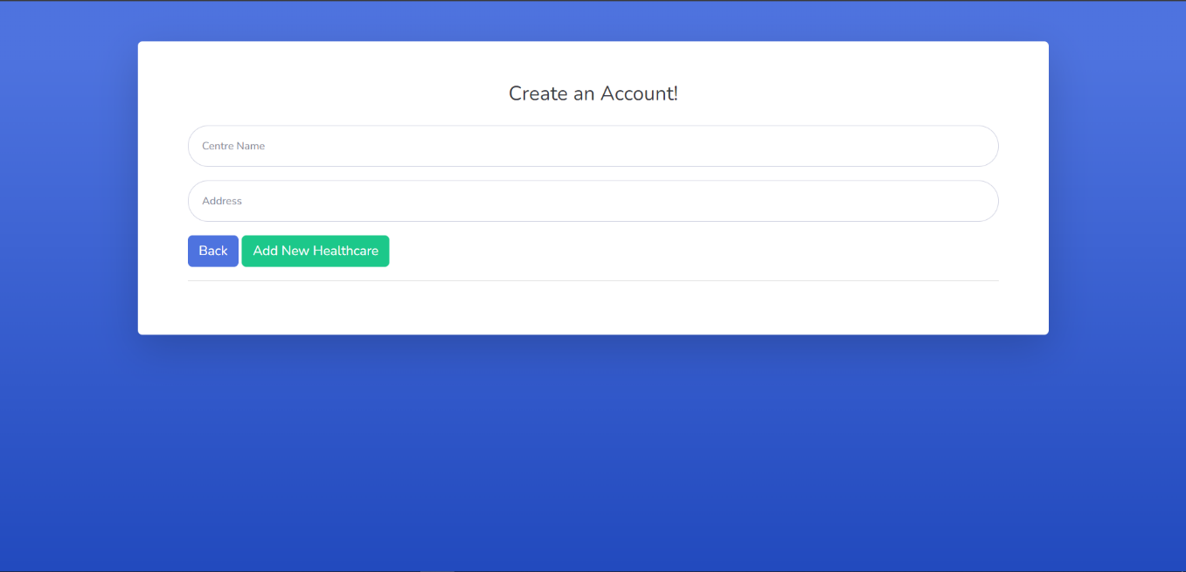

1. **Login**

This is the login page

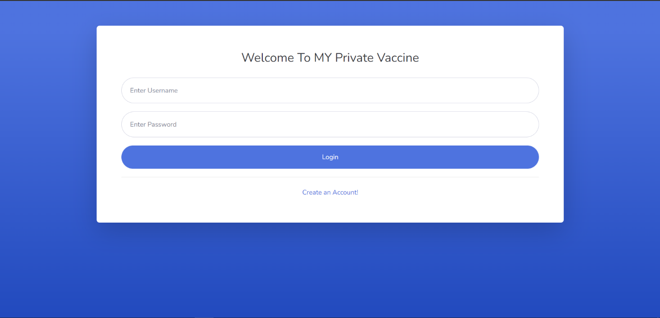

When patient enter match password and username, display menu based on their role

* If user is a patient

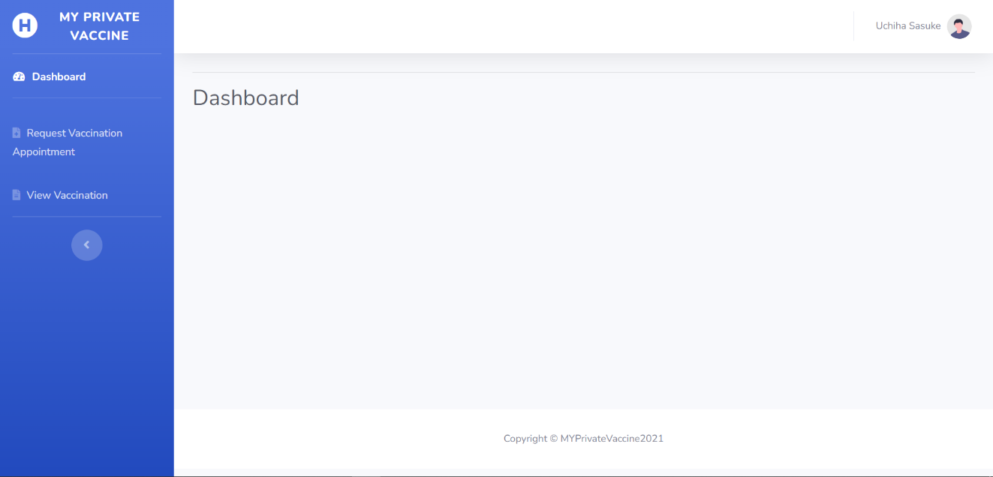

* If user is a healthcare administrator

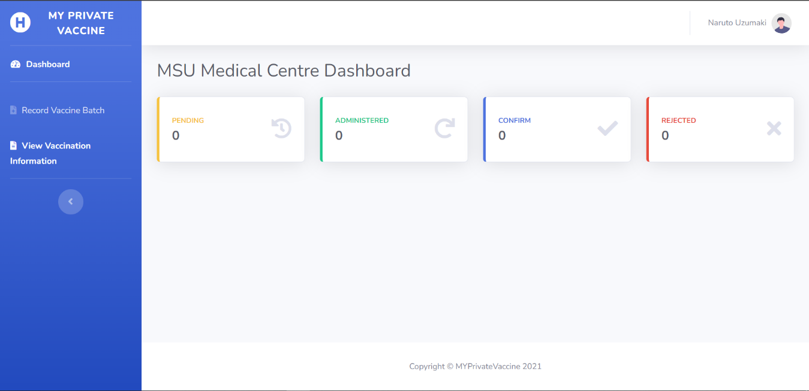

1. **Record New Vaccine Batch**

Below is the display when healthcare administrator click the record new vaccine batch. It still has no data because healthcare administrator did not record new vaccine batch yet

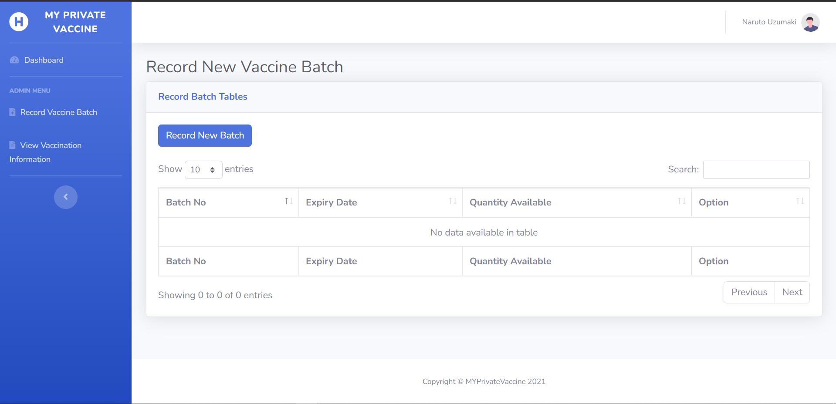

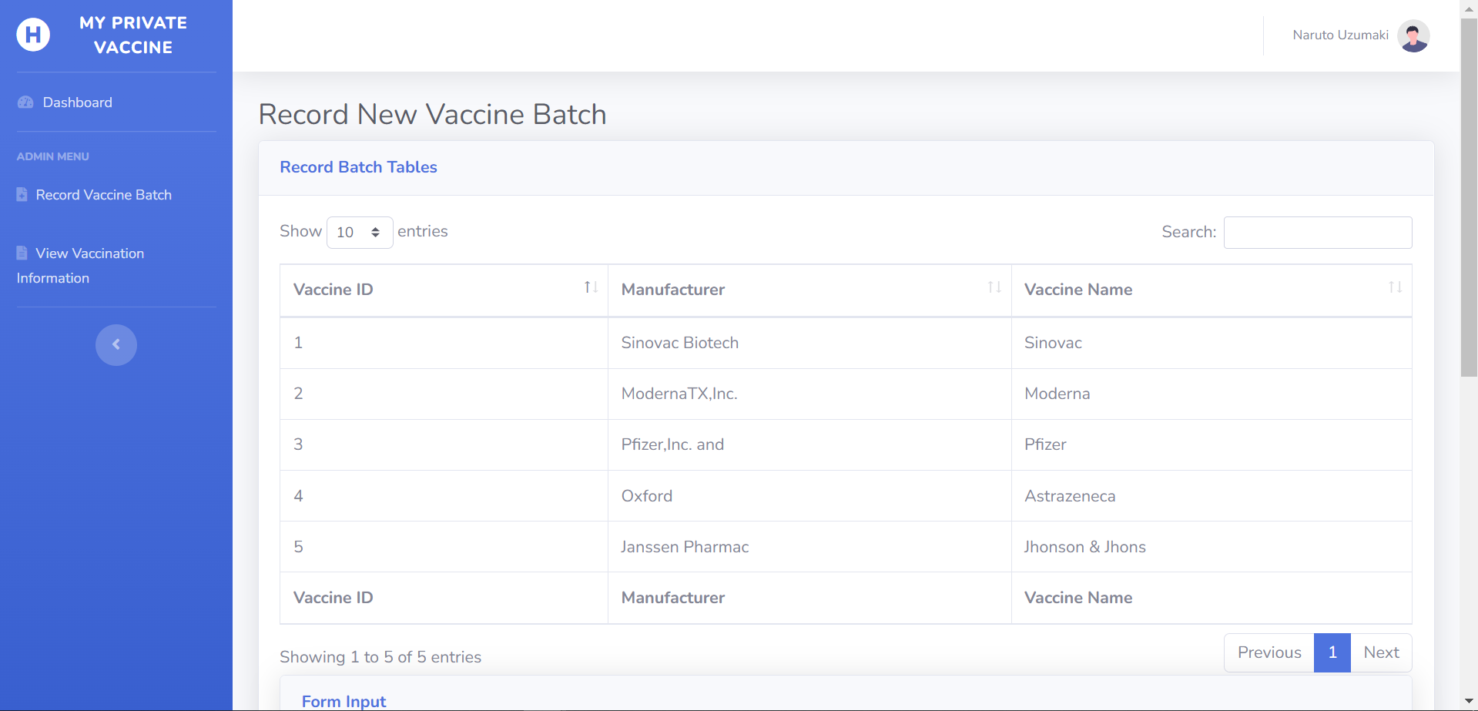

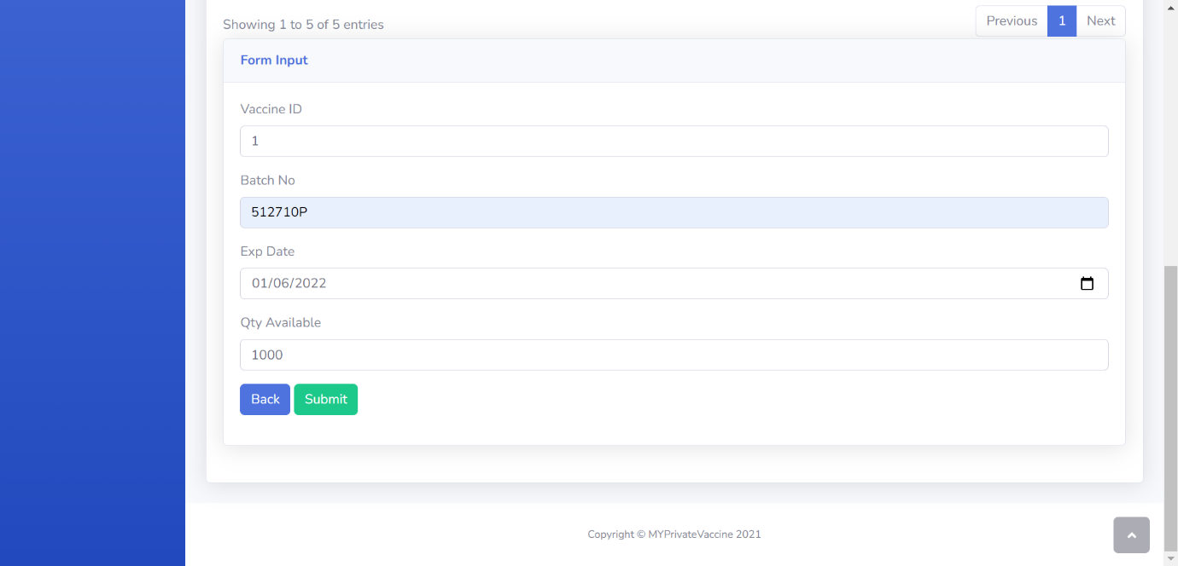

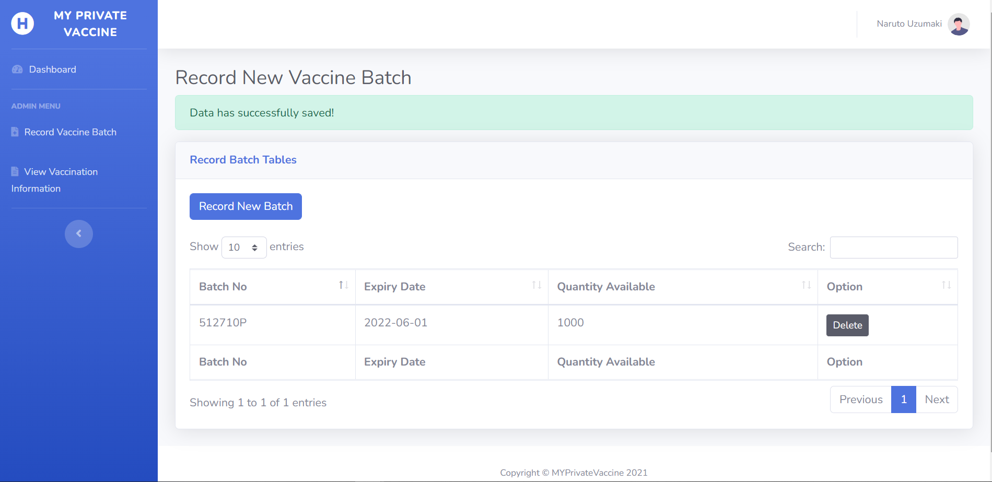

1. **Request Vaccination Appointment**

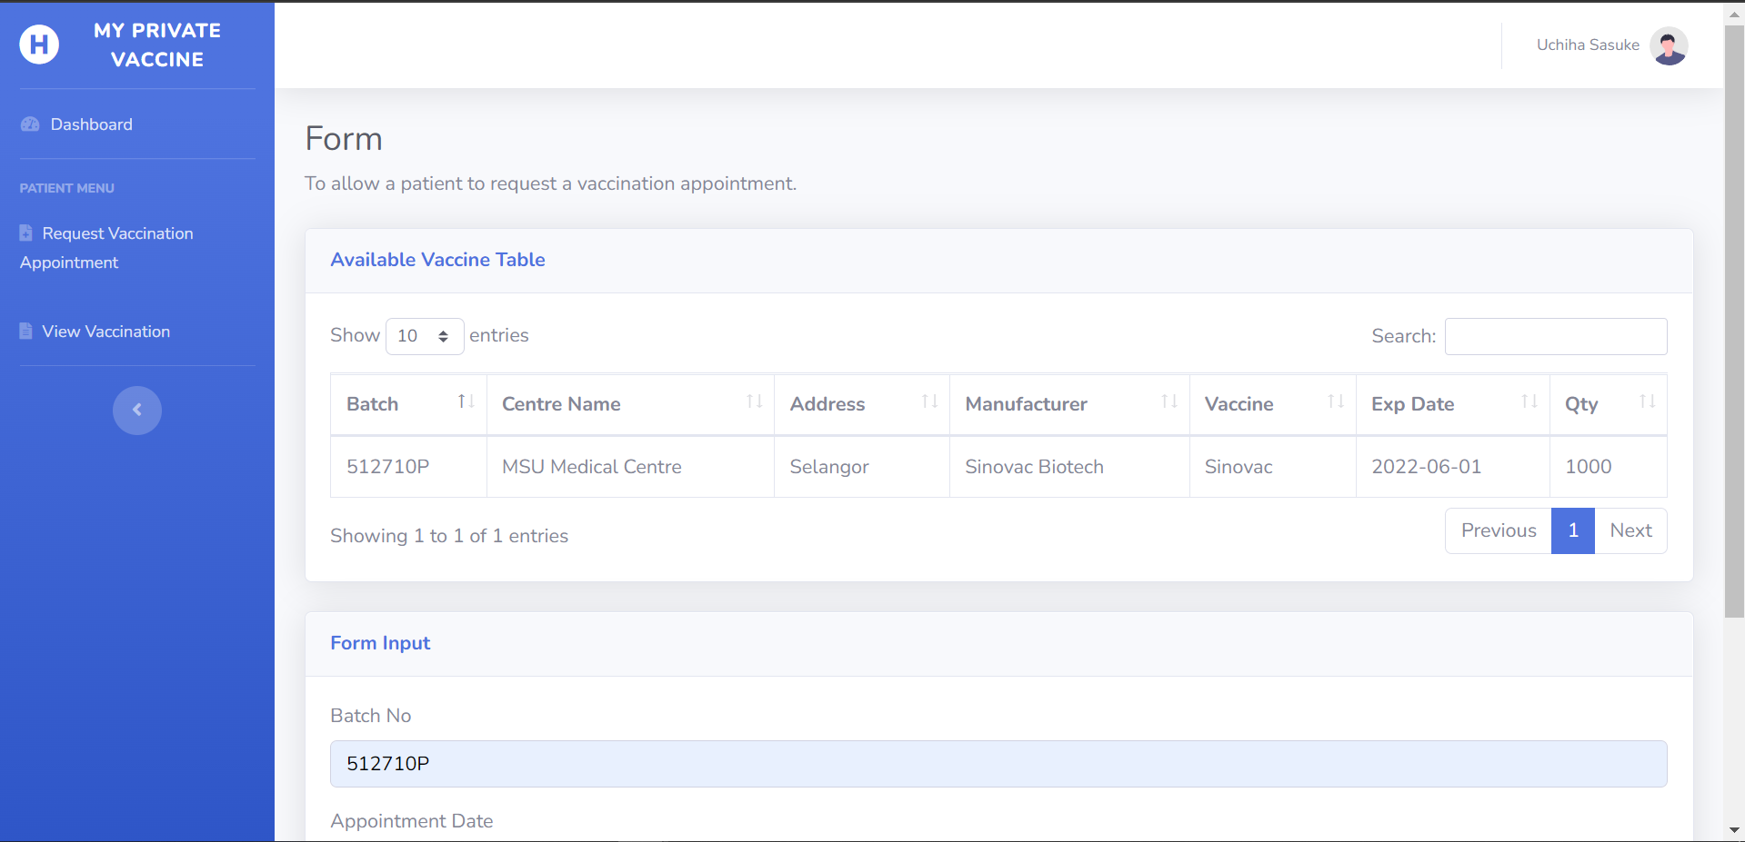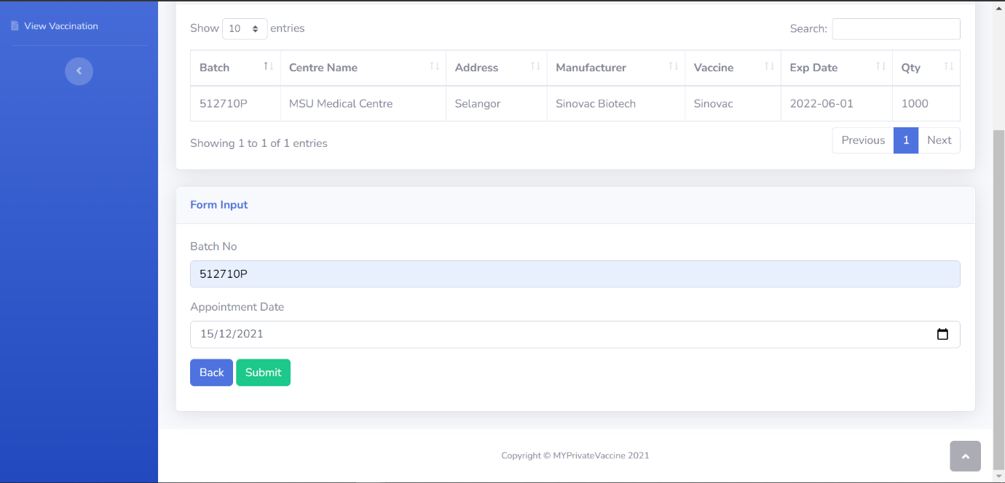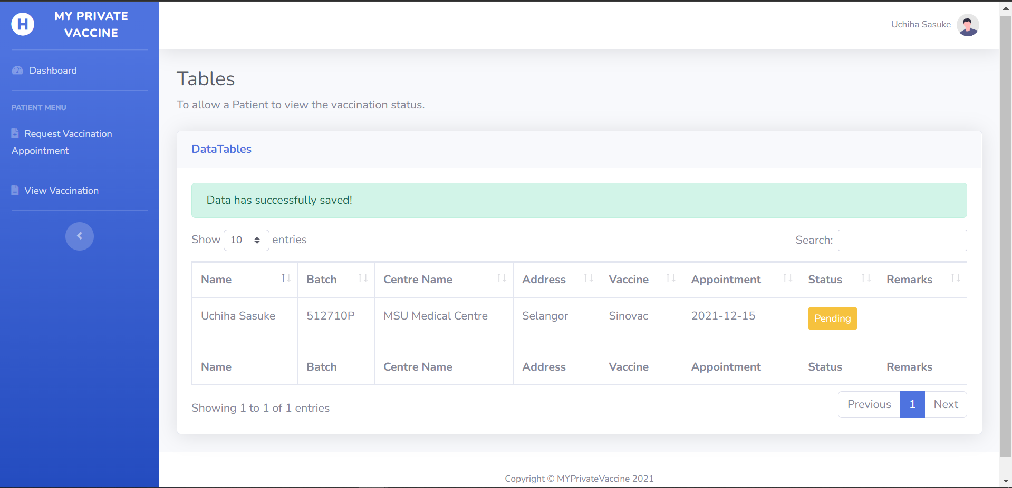

1. **View Vaccine Information**

Below is the display when healthcare administrator click the view vaccine batch information.

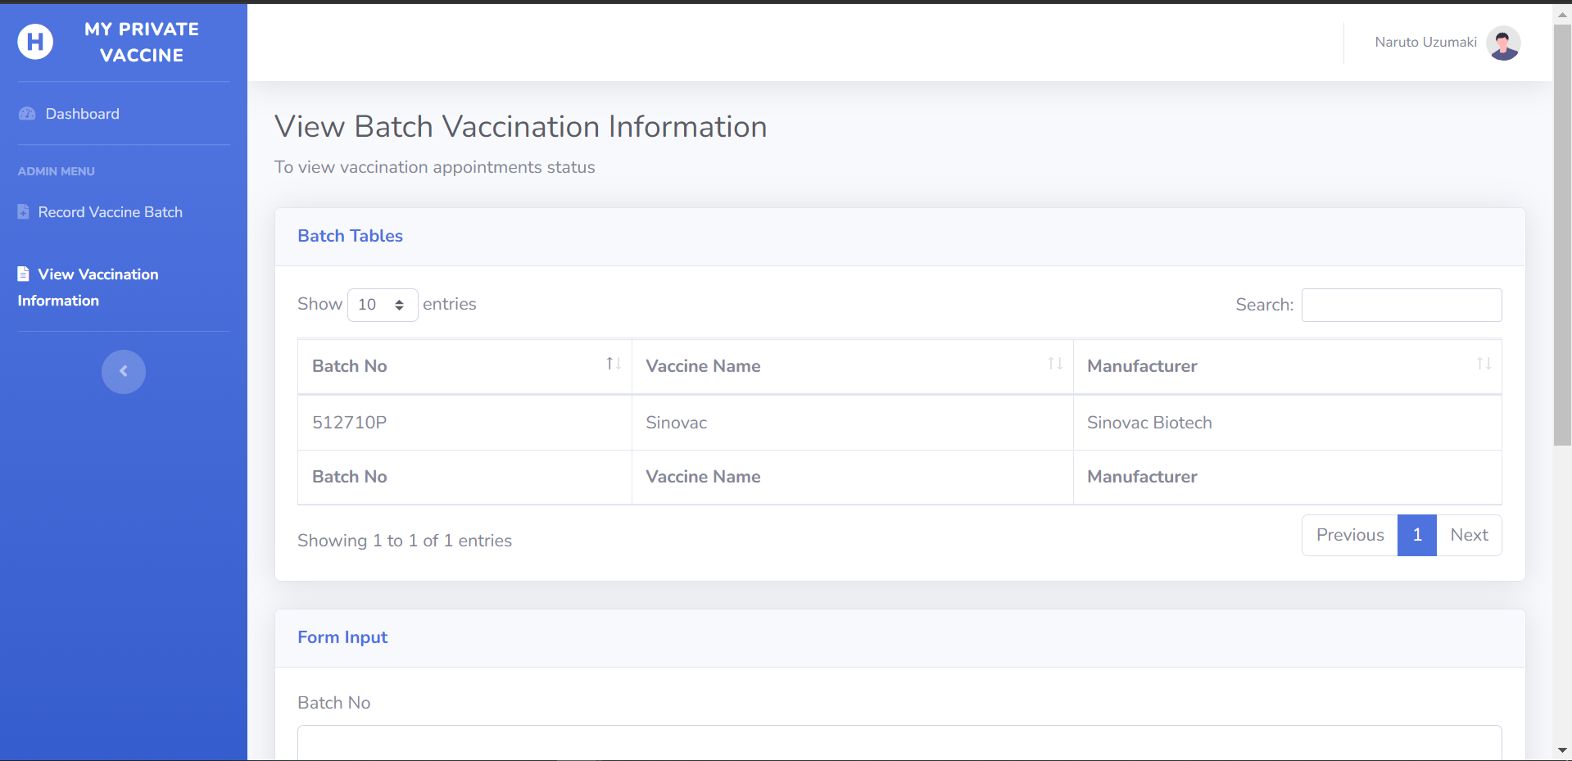

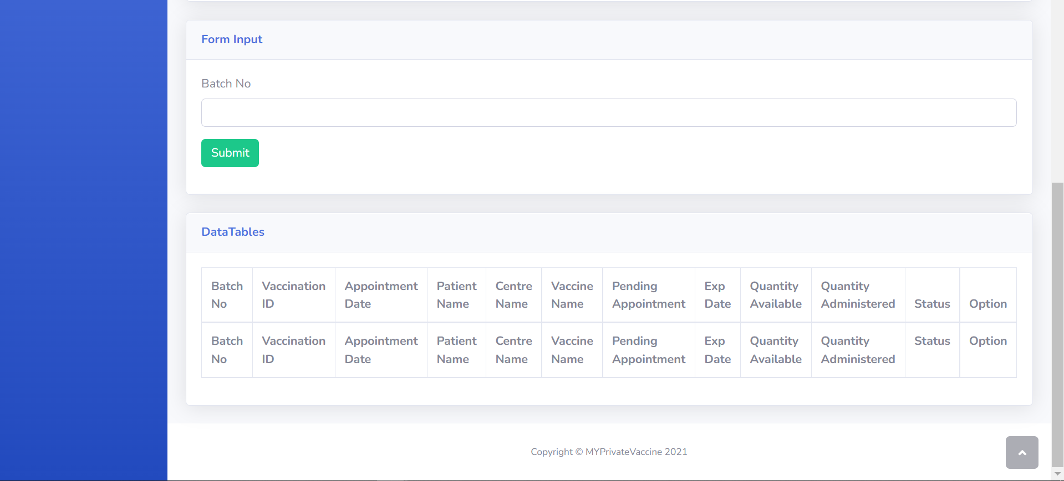

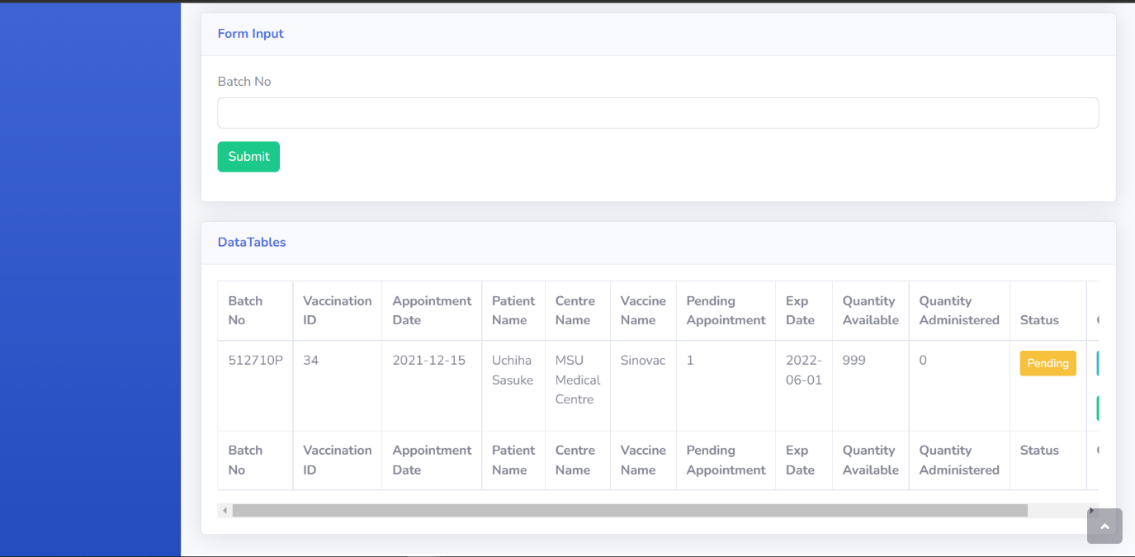

1. **Confirm Vaccination Appointment**

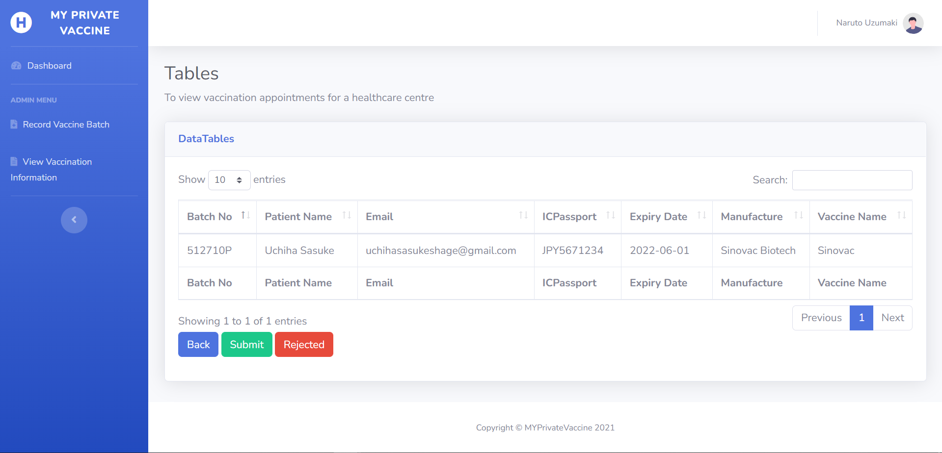

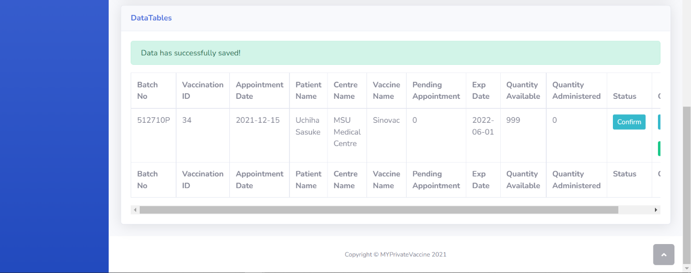

1. **Reject Vaccination Appointment**

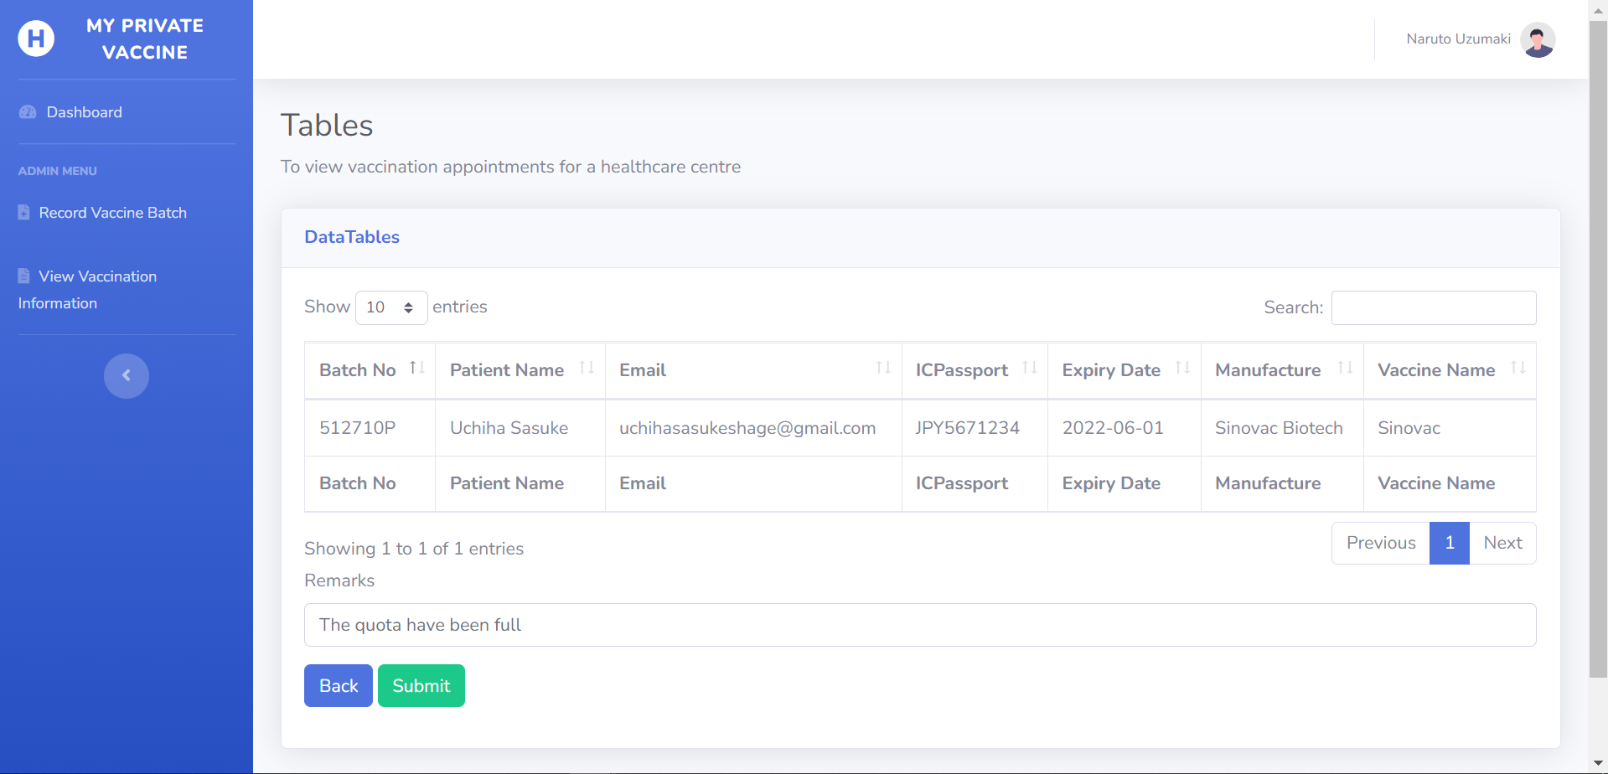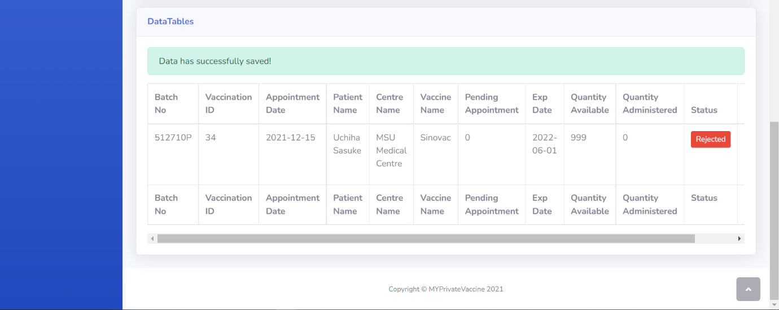

1. **Record Vaccination Administered**

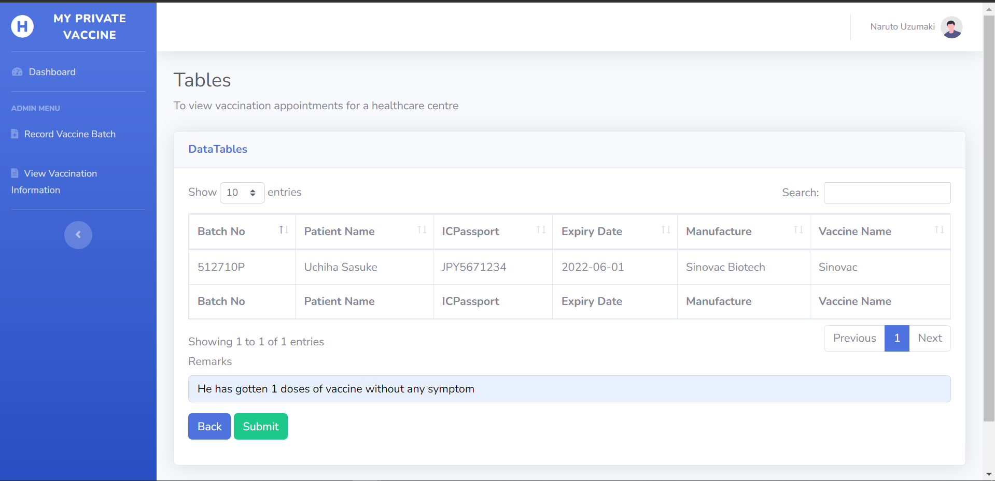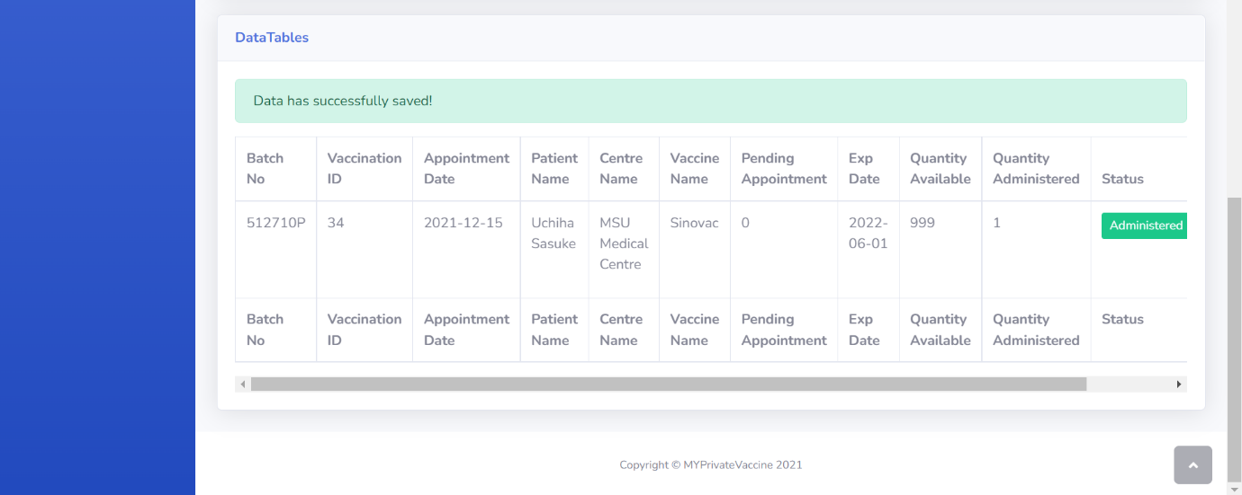

1. **View Vaccination Status**

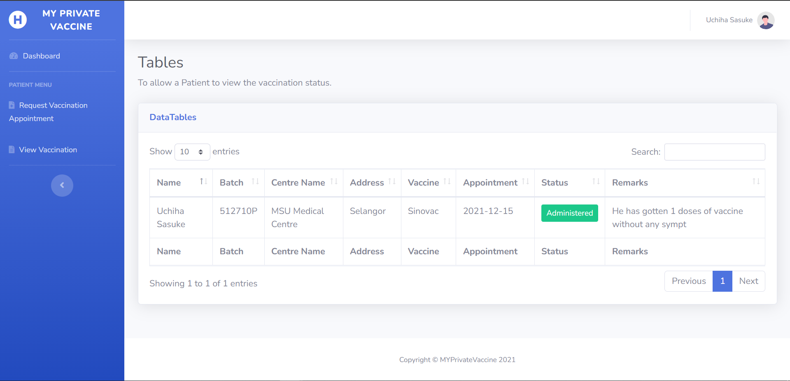

1. **Logout**

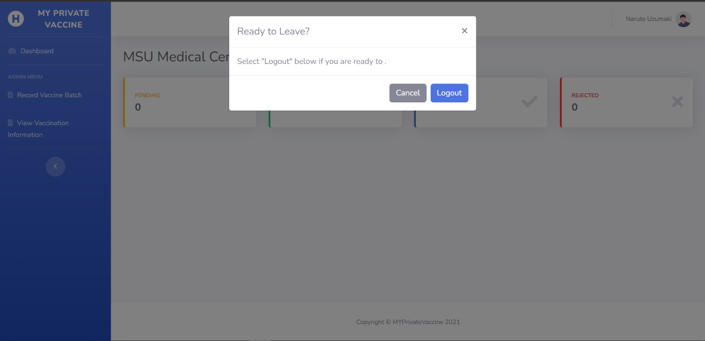

## **Test Objectives**

The testing approach is followed to guarantee that the use cases produced in this project's second iteration operate as planned. All of the requirements objectives for the remaining use cases that have been defined are listed below:

1. Healthcare administrator can record new vaccine batch, and the new vaccine recorded can be displayed throughout various use cases that needed it.
2. Healthcare administrator can view vaccine batch information which contain vaccination appointment made by patients.
3. Healthcare administrator can confirm or reject any vaccination appointment by choosing which vaccination appointment to manage.
4. Healthcare administrator can record any vaccination appointment as administered by choosing which vaccination appointment with the status confirm to be recorded as administered.
5. Patient can request vaccination appointment by choosing the vaccine they want
6. Patient can view their vaccination appointment status, it will be displayed as:

* Confirm, when the vaccination appointment confirmed but not yet administered
* Rejected, when the vaccination appointment rejected
* Administered, when the vaccination is administered

1. System can be utilized on a variety of devices
2. The user interface operates in accordance with its functions.

## **Test Plan**

|  |  |  |  |
| --- | --- | --- | --- |
| Testing type | Strategy | Tools | Schedule |
| Unit:   1. Record new vaccine batch 2. View vaccine batch information 3. Confirm vaccination appointment 4. Record Vaccination Administered 5. Request vaccination appointment 6. View vaccination status | Black box | Selenium | according to the Gantt chart's schedule  (12/01/2020 - 12/17/2020) |
| Integration | Black box | Selenium | according to the Gantt chart's schedule  (12/01/2020 - 12/17/2020) |
| Functional | Black box | Selenium | according to the Gantt chart's schedule  (12/01/2020 - 12/17/2020) |
| Non-functional | Black box | Google Chrome | according to the Gantt chart's schedule  (12/01/2020 - 12/17/2020) |

## **Test Results**

### **Unit Testing**

1. **Sign Up (Patient)**

|  |  |  |  |  |  |
| --- | --- | --- | --- | --- | --- |
| Test ID | R-01 | | | | |
| Use Case | Sign Up (patient) | | | | |
| Test Description | To allow user(patient) to register to the system | | | | |
| Source Code |  | | | | |
|  | | Test Data | Expected output | Actual output | Remark(s) |
| Test case 1: | | * Username: uchiha * Password: sasuke123 * Email: uchihasasuke@gmail.com * Full Name: Uchiha Sasuke * ICPaspport: JPY5671234 | Success message displayed, direct user to login menu, data enter will be stored in the database. | Success message displayed, direct user to login menu, data enter will be stored in the database. | pass |
| Test case 2: | | * Username: * Password: * Email: * Full Name: * ICPaspport: | Warning message displayed, stay on the sign up page | Warning message displayed, stay on the sign up page | pass |
| Test case 3: | | * Username: uchiha * Password: itachi123 * Email: itachiuchiha@gmail.com * Full Name: Itachi Uchiha   ICPaspport: JPY2648576 | Warning message indicate username used shown | Warning message indicate username used shown | pass |

1. **Sign Up (Healthcare Administrator)**

|  |  |  |  |  |  |
| --- | --- | --- | --- | --- | --- |
| Test ID | R-02 | | | | |
| Use Case | Sign Up (healthcare administrator) | | | | |
| Test Description | To allow user(healthcare administrator) to register to the system | | | | |
| Source Code |  | | | | |
|  | | Test Data | Expected output | Actual output | Remark(s) |
| Test case 1: | | * Username: uzumaki * Password: naruto123 * Email: uzumakinaruto@gmail.com * Full Name: Naruto Uzumaki * Center Name: MSU Medical Centre | Success message displayed, direct user to login menu, data enter will be stored in the database. | Success message displayed, direct user to login menu, data enter will be stored in the database. | Pass |
| Test case 2: | | * Username: * Password: * Email: * Full Name: * Center Name: | Warning message displayed, stay on the sign up page | Warning message displayed, stay on the sign up page | Pass |
| Test case 3: | | * Username: uzumaki * Password: boruto123 * Email: uzumakiboruto@gmail.com * Full Name: Boruto Uzumaki * Center Name: MSU Medical Centre | Warning message indicate username used shown | Warning message indicate username used shown | pass |

1. **Sign Up (Healthcare administrator add healthcare center)**

|  |  |  |  |  |  |
| --- | --- | --- | --- | --- | --- |
| Test ID | R-03 | | | | |
| Use case | Sign-up 🡪Add new Healthcare | | | | |
| Test description | To allow user to add new healthcare if there are no suitable healthcares | | | | |
| Source code |  | | | | |
|  | | Test data | Expected output | Actual output | Remark(s) |
| Test case 1: | | * Centre Name: BROSS Hospital * Address: Denpasar | Success message displayed, direct user to sign-up page, data enter will be stored in the database. | Success message displayed, direct user to sign-up page, data enter will be stored in the database. | Pass |

1. **Login**

|  |  |  |  |  |  |
| --- | --- | --- | --- | --- | --- |
| Test ID | R-04 | | | | |
| Use Case | Login | | | | |
| Test Description | To allow user to login to the system and display their menu according to their role | | | | |
| Source Code |  | | | | |
|  | | Test Data | Expected output | Actual output | Remark(s) |
| Test case 1: | | * Username: uchiha * Password: sasuke123 | Direct to patient home page | Direct to patient home page | Pass |
| Test case 2: | | * Username: uzumaki * Password: naruto123 | Direct to healthcare administrator home page, display center name | Direct to healthcare administrator home page, display center name | Pass |
| Test case 3: | | * Username: uzumaki * Password: naruto | Display error notification, stay on login page, both field emptied | Display error notification, stay on login page, both field emptied | Pass |

1. **Record New Vaccine Batch**

|  |  |  |  |  |  |
| --- | --- | --- | --- | --- | --- |
| Test ID | R-05 | | | | |
| Use case | Record New Vaccine Batch | | | | |
| Test description | To allow administrator to record new vaccine batch | | | | |
| Source code |  | | | | |
|  | | Test data | Expected output | Actual output | Remark(s) |
| Test case 1: | | * Vaccine ID: 1 * Batch No: 512710P * Expiry Date: 01-06-2022 * Quantity: 100 | Success message displayed, direct user to view batch page, data enter will be stored in the database. | Success message displayed, direct user to view batch page, data enter will be stored in the database. | pass |
| Test case 2: | | * Vaccine ID: 10 * Batch No: 513891A * Expiry Date: 01-10-2022 * Quantity: 100 | Warning message displayed, stay on the form-record batch page | Warning message displayed, stay on the form-record batch page | pass |

1. **Request Vaccination Appointment**

|  |  |  |  |  |  |
| --- | --- | --- | --- | --- | --- |
| Test ID | R-06 | | | | |
| Use case | Request Vaccination Appointment | | | | |
| Test description | To allow user to request vaccination appointment | | | | |
| Source code |  | | | | |
|  | | Test data | Expected output | Actual output | Remark(s) |
| Test case 1: | | * Batch No: 512710P * Appointment Date: 20-12-2021 | Success message displayed, direct user to view vaccination status page, data enter will be stored in the database. | Success message displayed, direct user to view vaccination status page, data enter will be stored in the database. | pass |
| Test case 2: | | * Batch No: 512710A * Appointment Date: 20-12-2021 | Warning message displayed, stay on the request vaccination appointment page | Warning message displayed, stay on the request vaccination appointment page | Pass |

1. **View Vaccination Information**

|  |  |  |  |  |  |
| --- | --- | --- | --- | --- | --- |
| Test ID | R-7 | | | | |
| Use case | View Vaccination Information | | | | |
| Test description | To allow user to view vaccination information | | | | |
| Source code |  | | | | |
|  | | Test data | Expected output | Actual output | Remark(s) |
| Test case 1: | | * Batch No: 512710P | Detail Batch information  Displayed, user stay in view vaccination information page | Detail Batch information  Displayed, user stay in view vaccination information page | Pass |

1. **Confirm Vaccination Appointment**

|  |  |  |  |  |
| --- | --- | --- | --- | --- |
| Test ID | R-08 | | | |
| Use case | Confirm Vaccination appointment | | | |
| Test description | To allow user to confirm vaccination appointment | | | |
|  |  | | | |
|  | Test data | Expected output | Actual output | Remark(s) |
| Test case 1: | * Click submit button | Success message Displayed, email notification is automatically send to patient, redirect user to view vaccination information page, data will be stored in the database. | Success message Displayed, email notification is automatically send to patient, redirect user to view vaccination information page, data will be stored in the database. | Pass |
| Test case 2 | * Click Reject button | Redirect user to reject vaccination appointment page | Redirect user to reject vaccination appointment page | Pass |
| Test case 3 | * Click Back button | Redirect user to view vaccination information page | Redirect user to view vaccination information page | Pass |

1. **Reject Vaccination Appointment**

|  |  |  |  |  |  |
| --- | --- | --- | --- | --- | --- |
| Test ID | R-09 | | | | |
| Use case | Reject vaccination appointment | | | | |
| Test description | To allow user to reject vaccination appointment | | | | |
| Source code |  | | | | |
|  | | Test data | Expected output | Actual output | Remark(s) |
| Test case 1: | | * Remarks: quota for the vaccination has been full * Click Submit button | Success message Displayed, email notification is automatically send to patient, redirect user to view vaccination information page, data will be stored in the database. | Success message Displayed, email notification is automatically send to patient, redirect user to view vaccination information page, data will be stored in the database. | Pass |
| Test case 2 | | * Click Back button | Redirect user to view vaccination information page | Redirect user to view vaccination information page | Pass |

1. **Record Vaccination Administered**

|  |  |  |  |  |  |
| --- | --- | --- | --- | --- | --- |
| Test ID | R-10 | | | | |
| Use case | Record vaccination administered | | | | |
| Test description | To allow user to record vaccination administered | | | | |
| Source code |  | | | | |
|  | | Test data | Expected output | Actual output | Remark(s) |
| Test case 1: | | * Remarks: He has gotten 1 doses of vaccine without any symptom * Click Submit button | Success message Displayed, redirect user to view vaccination information page, data will be stored in the database. | Success message Displayed, redirect user to view vaccination information page, data will be stored in the database. | Pass |

1. **View Vaccination Status**

|  |  |  |  |  |  |
| --- | --- | --- | --- | --- | --- |
| Test ID | R-11 | | | | |
| Use case | View vaccination status | | | | |
| Test description | To allow user to view vaccination status | | | | |
| Source code |  | | | | |
|  | | Test data | Expected output | Actual output | Remark(s) |
| Test case 1: | | * Click view vaccination status menu | Vaccination information displayed | Vaccination information displayed | Pass |

1. **Logout**

|  |  |  |  |  |  |
| --- | --- | --- | --- | --- | --- |
| Test ID | R-12 | | | | |
| Use Case | Logout | | | | |
| Test Description | To allow user to logout from the system | | | | |
| Source Code |  | | | | |
|  | | Test Data | Expected output | Actual output | Remark(s) |
| Test Case 1: | | Click logout button | Confirmation message displayed | Confirmation message displayed | Pass |
| Test Case 2: | | Click ‘cancel’ button on the logout confirmation | Stay on the pervious page | Stay on the pervious page | Pass |
| Test Case 3: | | Click ‘yes’ button on the logout confirmation | Session ended, directing back to login menu | Session ended, directing back to login menu | Pass |

### **Integration Testing**

1. **Sign Up (Patient)**

|  |  |  |  |  |  |
| --- | --- | --- | --- | --- | --- |
| Test ID | R-01 | | | | |
| Use Case | Sign Up (patient) | | | | |
| Test Description | To allow user(patient) to register to the system | | | | |
|  | | Test Data | Expected output | Actual output | Remark(s) |
| Test case 1: | | * Username: uchiha * Password: sasuke123 * Email: uchihasasuke@gmail.com * Full Name: Uchiha Sasuke * ICPaspport: JPY5671234 | Success message displayed, direct user to login menu, data enter will be stored in the database. | Success message displayed, direct user to login menu, data enter will be stored in the database. | pass |
| Test case 2: | | * Username: * Password: * Email: * Full Name: * ICPaspport: | Warning message displayed, stay on the sign up page | Warning message displayed, stay on the sign up page | pass |
| Test case 3: | | * Username: uchiha * Password: itachi123 * Email: itachiuchiha@gmail.com * Full Name: Itachi Uchiha * ICPaspport: JPY2648576 | Warning message indicate username used shown | Warning message indicate username used shown | pass |

1. **Sign Up (Healthcare Administrator)**

|  |  |  |  |  |  |
| --- | --- | --- | --- | --- | --- |
| Test ID | R-02 | | | | |
| Use Case | Sign Up (healthcare administrator) | | | | |
| Test Description | To allow user(healthcare administrator) to register to the system | | | | |
|  | | Test Data | Expected output | Actual output | Remark(s) |
| Test case 1: | | * Username: uzumaki * Password: naruto123 * Email: uzumakinaruto@gmail.com * Full Name: Naruto Uzumaki * Center Name: MSU Medical Centre | Success message displayed, direct user to login menu, data enter will be stored in the database. | Success message displayed, direct user to login menu, data enter will be stored in the database. | Pass |
| Test case 2: | | * Username: * Password: * Email: * Full Name: * Center Name: | Warning message displayed, stay on the sign up page | Warning message displayed, stay on the sign up page | Pass |
| Test case 3: | | * Username: uzumaki * Password: boruto123 * Email: uzumakiboruto@gmail.com * Full Name: Boruto Uzumaki * Center Name: MSU Medical Centre | Warning message indicate username used shown | Warning message indicate username used shown | pass |

1. **Sign Up (Healthcare administrator add healthcare center)**

|  |  |  |  |  |  |
| --- | --- | --- | --- | --- | --- |
| Test ID | R-03 | | | | |
| Use case | Sign-up 🡪Add new Healthcare | | | | |
| Test description | To allow user to add new healthcare if there are no suitable healthcares | | | | |
|  | | Test data | Expected output | Actual output | Remark(s) |
| Test case 1: | | * Centre Name: BROSS Hospital * Address: Denpasar | Success message displayed, direct user to sign-up page, data enter will be stored in the database. | Success message displayed, direct user to sign-up page, data enter will be stored in the database. | Pass |

1. **Login**

|  |  |  |  |  |  |
| --- | --- | --- | --- | --- | --- |
| Test ID | R-04 | | | | |
| Use Case | Login | | | | |
| Test Description | To allow user to login to the system and display their menu according to their role | | | | |
|  | | Test Data | Expected output | Actual output | Remark(s) |
| Test case 1: | | * Username: uchiha * Password: sasuke123 | Direct to patient home page | Direct to patient home page | Pass |
| Test case 2: | | * Username: uzumaki * Password: naruto123 | Direct to healthcare administrator home page, display center name | Direct to healthcare administrator home page, display center name | Pass |
| Test case 3: | | * Username: uzumaki * Password: naruto | Display error notification, stay on login page, both field emptied | Display error notification, stay on login page, both field emptied | Pass |

1. **Record New Vaccine Batch**

|  |  |  |  |  |  |
| --- | --- | --- | --- | --- | --- |
| Test ID | R-05 | | | | |
| Use case | Record New Vaccine Batch | | | | |
| Test description | To allow administrator to record new vaccine batch | | | | |
|  | | Test data | Expected output | Actual output | Remark(s) |
| Test case 1: | | * Vaccine ID: 1 * Batch No: 512710P * Expiry Date: 01-06-2022 * Quantity: 100 | Success message displayed, direct user to view batch page, data enter will be stored in the database. | Success message displayed, direct user to view batch page, data enter will be stored in the database. | pass |
| Test case 2: | | * Vaccine ID: 10 * Batch No: 513891A * Expiry Date: 01-10-2022 * Quantity: 100 | Warning message displayed, stay on the form-record batch page | Warning message displayed, stay on the form-record batch page | pass |

1. **Request Vaccination Appointment**

|  |  |  |  |  |  |
| --- | --- | --- | --- | --- | --- |
| Test ID | R-06 | | | | |
| Use case | Request Vaccination Appointment | | | | |
| Test description | To allow user to request vaccination appointment | | | | |
|  | | Test data | Expected output | Actual output | Remark(s) |
| Test case 1: | | * Batch No: 512710P * Appointment Date: 20-12-2021 | Success message displayed, direct user to view vaccination status page, data enter will be stored in the database. | Success message displayed, direct user to view vaccination status page, data enter will be stored in the database. | pass |
| Test case 2: | | * Batch No: 512710A * Appointment Date: 20-12-2021 | Warning message displayed, stay on the request vaccination appointment page | Warning message displayed, stay on the request vaccination appointment page | Pass |

1. **View Vaccination Information**

|  |  |  |  |  |  |
| --- | --- | --- | --- | --- | --- |
| Test ID | R-07 | | | | |
| Use case | View Vaccination Information | | | | |
| Test description | To allow user to view vaccination information | | | | |
|  | | Test data | Expected output | Actual output | Remark(s) |
| Test case 1: | | * Batch No: 512710P | Detail Batch information  Displayed, user stay in view vaccination information page | Detail Batch information  Displayed, user stay in view vaccination information page | Pass |

1. **Confirm Vaccination Appointment**

|  |  |  |  |  |
| --- | --- | --- | --- | --- |
| Test ID | R-08 | | | |
| Use case | Confirm Vaccination appointment | | | |
| Test description | To allow user to confirm vaccination appointment | | | |
|  | Test data | Expected output | Actual output | Remark(s) |
| Test case 1: | * Click submit button | Success message Displayed, email notification is automatically send to patient, redirect user to view vaccination information page, data will be stored in the database. | Success message Displayed, email notification is automatically send to patient, redirect user to view vaccination information page, data will be stored in the database. | Pass |
| Test case 2 | * Click Reject button | Redirect user to reject vaccination appointment page | Redirect user to reject vaccination appointment page | Pass |
| Test case 3 | * Click Back button | Redirect user to view vaccination information page | Redirect user to view vaccination information page | Pass |

1. **Reject Vaccination Appointment**

|  |  |  |  |  |  |
| --- | --- | --- | --- | --- | --- |
| Test ID | R-09 | | | | |
| Use case | Reject vaccination appointment | | | | |
| Test description | To allow user to reject vaccination appointment | | | | |
|  | | Test data | Expected output | Actual output | Remark(s) |
| Test case 1: | | * Remarks: quota for the vaccination has been full * Click Submit button | Success message Displayed, email notification is automatically send to patient, redirect user to view vaccination information page, data will be stored in the database. | Success message Displayed, email notification is automatically send to patient, redirect user to view vaccination information page, data will be stored in the database. | Pass |
| Test case 2 | | * Click Back button | Redirect user to view vaccination information page | Redirect user to view vaccination information page | Pass |

1. **Record Vaccination Administered**

|  |  |  |  |  |  |
| --- | --- | --- | --- | --- | --- |
| Test ID | R-10 | | | | |
| Use case | Record vaccination administered | | | | |
| Test description | To allow user to record vaccination administered | | | | |
|  | | Test data | Expected output | Actual output | Remark(s) |
| Test case 1: | | * Remarks: He has gotten 1 doses of vaccine without any symptom * Click Submit button | Success message Displayed, redirect user to view vaccination information page, data will be stored in the database. | Success message Displayed, redirect user to view vaccination information page, data will be stored in the database. | Pass |

1. **View Vaccination Status**

|  |  |  |  |  |  |
| --- | --- | --- | --- | --- | --- |
| Test ID | R-11 | | | | |
| Use case | View vaccination status | | | | |
| Test description | To allow user to view vaccination status | | | | |
|  | | Test data | Expected output | Actual output | Remark(s) |
| Test case 1: | | * Click view vaccination status menu | Vaccination information displayed | Vaccination information displayed | Pass |

1. **Logout**

|  |  |  |  |  |  |
| --- | --- | --- | --- | --- | --- |
| Test ID | R-12 | | | | |
| Use Case | Logout | | | | |
| Test Description | To allow user to logout from the system | | | | |
|  | | Test Data | Expected output | Actual output | Remark(s) |
| Test Case 1: | | Click logout button | Confirmation message displayed | Confirmation message displayed | Pass |
| Test Case 2: | | Click ‘cancel’ button on the logout confirmation | Stay on the pervious page | Stay on the pervious page | Pass |
| Test Case 3: | | Click ‘yes’ button on the logout confirmation | Session ended, directing back to login menu | Session ended, directing back to login menu | Pass |

### **System Testing**

* Functional Requirements

1. **Sign Up (Patient)**

|  |  |  |  |  |  |
| --- | --- | --- | --- | --- | --- |
| Test ID | R-01 | | | | |
| Use Case | Sign Up (patient) | | | | |
| Test Description | To allow user(patient) to register to the system | | | | |
|  | | Test Data | Expected output | Actual output | Remark(s) |
| Test case 1: | | * Username: uchiha * Password: sasuke123 * Email: uchihasasuke@gmail.com * Full Name: Uchiha Sasuke * ICPaspport: JPY5671234 | Success message displayed, direct user to login menu, data enter will be stored in the database. | Success message displayed, direct user to login menu, data enter will be stored in the database. | pass |
| Test case 2: | | * Username: * Password: * Email: * Full Name: * ICPaspport: | Warning message displayed, stay on the sign up page | Warning message displayed, stay on the sign up page | pass |
| Test case 3: | | * Username: uchiha * Password: itachi123 * Email: itachiuchiha@gmail.com * Full Name: Itachi Uchiha * ICPaspport: JPY2648576 | Warning message indicate username used shown | Warning message indicate username used shown | pass |

1. **Sign Up (Healthcare Administrator)**

|  |  |  |  |  |  |
| --- | --- | --- | --- | --- | --- |
| Test ID | R-02 | | | | |
| Use Case | Sign Up (healthcare administrator) | | | | |
| Test Description | To allow user(healthcare administrator) to register to the system | | | | |
|  | | Test Data | Expected output | Actual output | Remark(s) |
| Test case 1: | | * Username: uzumaki * Password: naruto123 * Email: uzumakinaruto@gmail.com * Full Name: Naruto Uzumaki * Center Name: MSU Medical Centre | Success message displayed, direct user to login menu, data enter will be stored in the database. | Success message displayed, direct user to login menu, data enter will be stored in the database. | Pass |
| Test case 2: | | * Username: * Password: * Email: * Full Name: * Center Name: | Warning message displayed, stay on the sign up page | Warning message displayed, stay on the sign up page | Pass |
| Test case 3: | | * Username: uzumaki * Password: boruto123 * Email: uzumakiboruto@gmail.com * Full Name: Boruto Uzumaki * Center Name: MSU Medical Centre | Warning message indicate username used shown | Warning message indicate username used shown | pass |

1. **Sign Up (Healthcare administrator add healthcare center)**

|  |  |  |  |  |  |
| --- | --- | --- | --- | --- | --- |
| Test ID | R-03 | | | | |
| Use case | Sign-up 🡪Add new Healthcare | | | | |
| Test description | To allow user to add new healthcare if there are no suitable healthcares | | | | |
|  | | Test data | Expected output | Actual output | Remark(s) |
| Test case 1: | | * Centre Name: “BROSS Hospital” * Address: “Denpasar” | Success message displayed, direct user to sign-up page, data enter will be stored in the database. | Success message displayed, direct user to sign-up page, data enter will be stored in the database. | Pass |

1. **Login**

|  |  |  |  |  |  |
| --- | --- | --- | --- | --- | --- |
| Test ID | R-04 | | | | |
| Use Case | Login | | | | |
| Test Description | To allow user to login to the system and display their menu according to their role | | | | |
|  | | Test Data | Expected output | Actual output | Remark(s) |
| Test case 1: | | * Username: uchiha * Password: sasuke123 | Direct to patient home page | Direct to patient home page | Pass |
| Test case 2: | | * Username: uzumaki * Password: naruto123 | Direct to healthcare administrator home page, display center name | Direct to healthcare administrator home page, display center name | Pass |
| Test case 3: | | * Username: uzumaki * Password: naruto | Display error notification, stay on login page, both field emptied | Display error notification, stay on login page, both field emptied | Pass |

1. **Record New Vaccine Batch**

|  |  |  |  |  |  |
| --- | --- | --- | --- | --- | --- |
| Test ID | R-05 | | | | |
| Use case | Record New Vaccine Batch | | | | |
| Test description | To allow administrator to record new vaccine batch | | | | |
|  | | Test data | Expected output | Actual output | Remark(s) |
| Test case 1: | | * Vaccine ID: “1” * Batch No: “512710P” * Expiry Date: “01-06-2022” * Quantity: “100” | Success message displayed, direct user to view batch page, data enter will be stored in the database. | Success message displayed, direct user to view batch page, data enter will be stored in the database. | pass |
| Test case 2: | | * Vaccine ID: “10” * Batch No: “513891A” * Expiry Date: “01-10-2022” * Quantity: “100” | Warning message displayed, stay on the form-record batch page | Warning message displayed, stay on the form-record batch page | pass |

1. **Request Vaccination Appointment**

|  |  |  |  |  |  |
| --- | --- | --- | --- | --- | --- |
| Test ID | R-06 | | | | |
| Use case | Request Vaccination Appointment | | | | |
| Test description | To allow user to request vaccination appointment | | | | |
|  | | Test data | Expected output | Actual output | Remark(s) |
| Test case 1: | | * Batch No: “512710P” * Appointment Date: “20-12-2021” | Success message displayed, direct user to view vaccination status page, data enter will be stored in the database. | Success message displayed, direct user to view vaccination status page, data enter will be stored in the database. | pass |
| Test case 2: | | * Batch No: “512710A” * Appointment Date:” 20-12-2021” | Warning message displayed, stay on the request vaccination appointment page | Warning message displayed, stay on the request vaccination appointment page | Pass |

1. **View Vaccination Information**

|  |  |  |  |  |  |
| --- | --- | --- | --- | --- | --- |
| Test ID | R-07 | | | | |
| Use case | View Vaccination Information | | | | |
| Test description | To allow user to view vaccination information | | | | |
|  | | Test data | Expected output | Actual output | Remark(s) |
| Test case 1: | | * Batch No: “512710P” | Detail Batch information  Displayed, user stay in view vaccination information page | Detail Batch information  Displayed, user stay in view vaccination information page | Pass |

1. **Confirm Vaccination Appointment**

|  |  |  |  |  |  |
| --- | --- | --- | --- | --- | --- |
| Test ID | R-08 | | | | |
| Use case | Confirm Vaccination appointment | | | | |
| Test description | To allow user to confirm vaccination appointment | | | | |
|  | | Test data | Expected output | Actual output | Remark(s) |
| Test case 1: | | * Click submit button | Success message Displayed, email notification is automatically send to patient, redirect user to view vaccination information page, data will be stored in the database. | Success message Displayed, email notification is automatically send to patient, redirect user to view vaccination information page, data will be stored in the database. | Pass |
| Test case 2 | | * Click Reject button | Redirect user to reject vaccination appointment page | Redirect user to reject vaccination appointment page | Pass |
| Test case 3 | | * Click Back button | Redirect user to view vaccination information page | Redirect user to view vaccination information page | Pass |

1. **Reject Vaccination Appointment**

|  |  |  |  |  |  |
| --- | --- | --- | --- | --- | --- |
| Test ID | R-09 | | | | |
| Use case | Reject vaccination appointment | | | | |
| Test description | To allow user to reject vaccination appointment | | | | |
|  | | Test data | Expected output | Actual output | Remark(s) |
| Test case 1: | | * Remarks: “quota for the vaccination has been full” * Click Submit button | Success message Displayed, email notification is automatically send to patient, redirect user to view vaccination information page, data will be stored in the database. | Success message Displayed, email notification is automatically send to patient, redirect user to view vaccination information page, data will be stored in the database. | Pass |
| Test case 2 | | * Click Back button | Redirect user to view vaccination information page | Redirect user to view vaccination information page | Pass |

1. **Record Vaccination Administered**

|  |  |  |  |  |  |
| --- | --- | --- | --- | --- | --- |
| Test ID | R-10 | | | | |
| Use case | Record vaccination administered | | | | |
| Test description | To allow user to record vaccination administered | | | | |
|  | | Test data | Expected output | Actual output | Remark(s) |
| Test case 1: | | * Remarks: “He has gotten 1 doses of vaccine without any symptom” * Click Submit button | Success message Displayed, redirect user to view vaccination information page, data will be stored in the database. | Success message Displayed, redirect user to view vaccination information page, data will be stored in the database. | Pass |

1. **View Vaccination Status**

|  |  |  |  |  |  |
| --- | --- | --- | --- | --- | --- |
| Test ID | R-11 | | | | |
| Use case | View vaccination status | | | | |
| Test description | To allow user to view vaccination status | | | | |
|  | | Test data | Expected output | Actual output | Remark(s) |
| Test case 1: | | * Click view vaccination status menu | Vaccination information displayed | Vaccination information displayed | Pass |

1. **Logout**

|  |  |  |  |  |  |
| --- | --- | --- | --- | --- | --- |
| Test ID | R-04 | | | | |
| Use Case | Logout | | | | |
| Test Description | To allow user to logout from the system | | | | |
|  | | Test Data | Expected output | Actual output | Remark(s) |
| Test Case 1: | | Click logout button | Confirmation message displayed | Confirmation message displayed | Pass |
| Test Case 2: | | Click ‘cancel’ button on the logout confirmation | Stay on the pervious page | Stay on the pervious page | Pass |
| Test Case 3: | | Click ‘yes’ button on the logout confirmation | Session ended, directing back to login menu | Session ended, directing back to login menu | Pass |

* Non-Functional Requirements

1. **Compatibility**

Accessible to most browser, here we choose Microsoft Edge and Google Chrome as an example

* Microsoft Edge

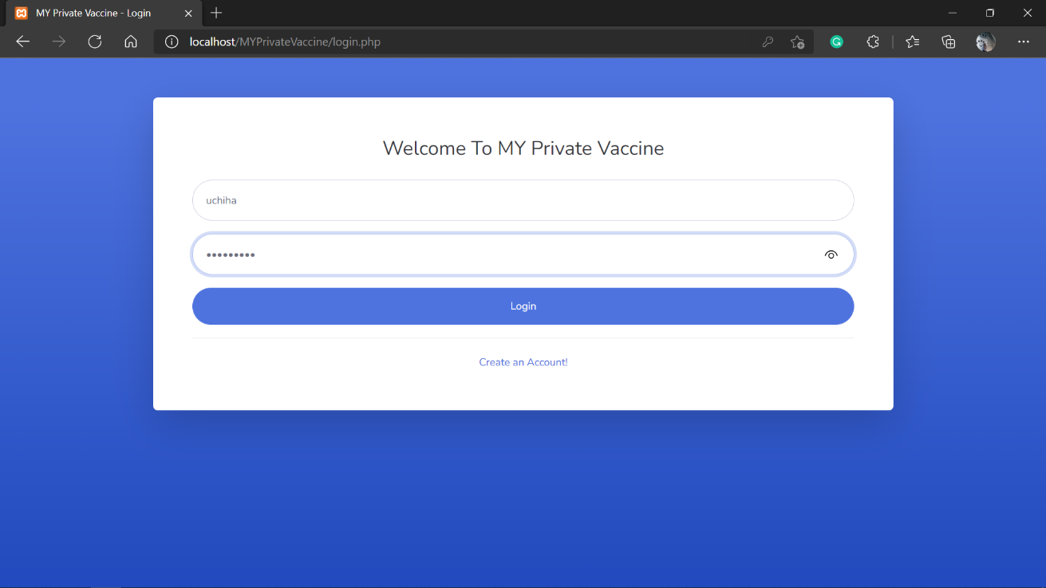

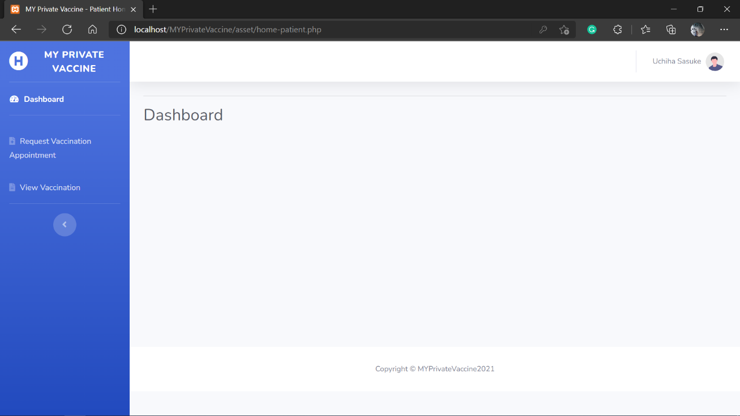

* Google Chrome

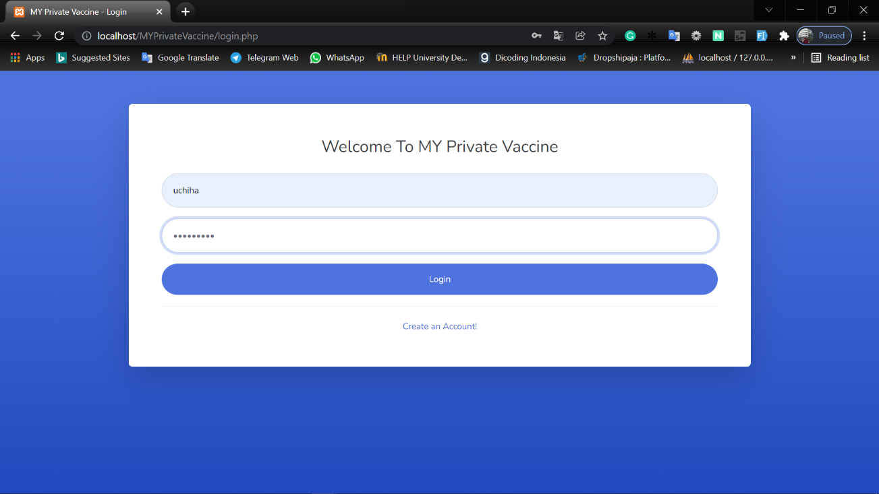

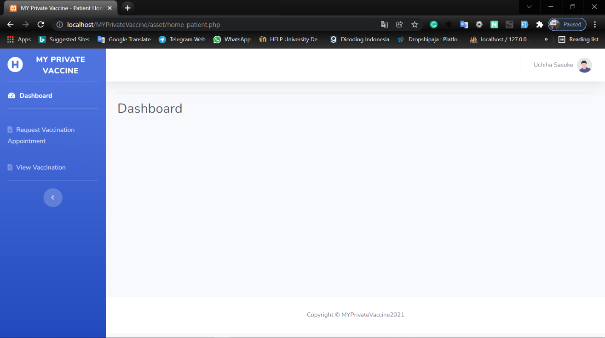

1. **Security**

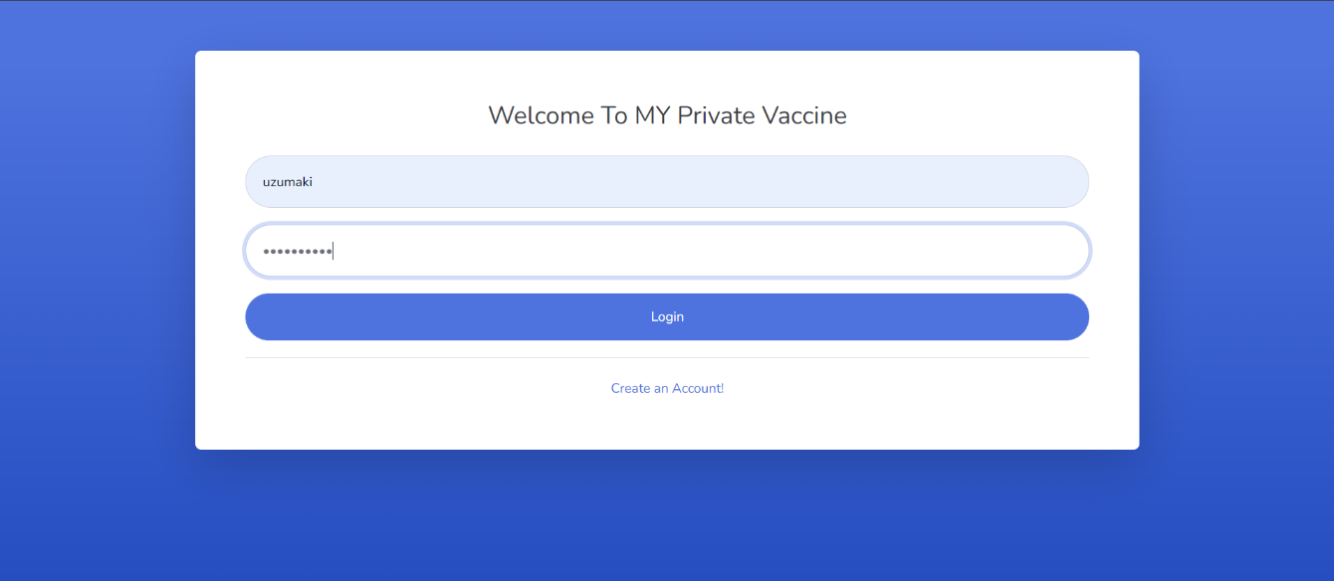

|  |  |  |  |  |  |
| --- | --- | --- | --- | --- | --- |
| Test ID | R-03 | | | | |
| Use Case | Login | | | | |
| Test Description | To allow user to login to the system and display their menu according to their role | | | | |
|  | | Test Data | Expected output | Actual output | Remark(s) |
| Test case 1: | | * Username: uchiha * Password: sasuke123 | Password field changed to “•••” | Password field changed to “•••” | Pass |

1. **Usability**

User friendly website with simple layout. System can also be accessed through smart phone. Dashboard example.

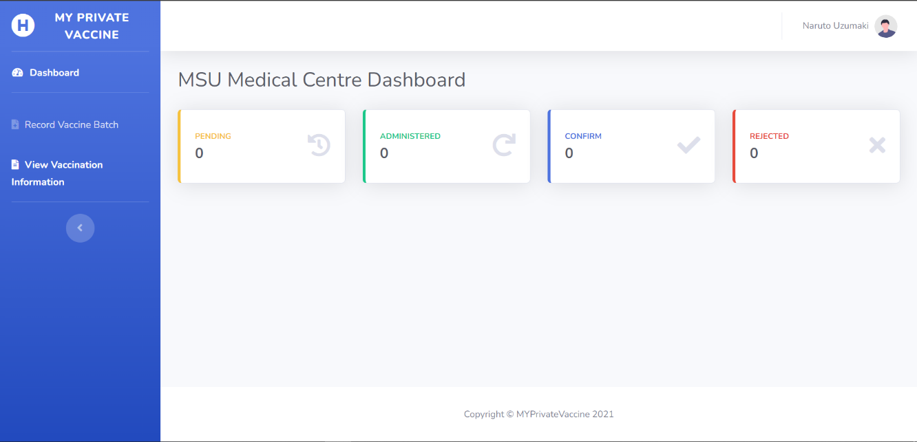

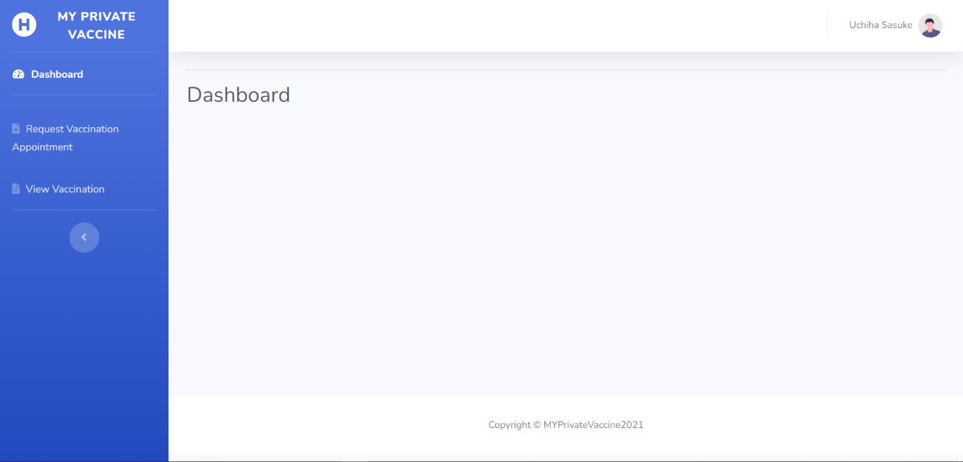

* Tablet

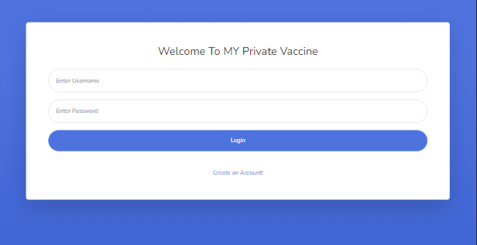

* Mobile Phone

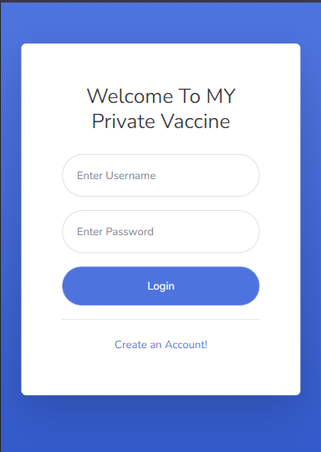

## **Test Analysis Report**

Unit testing, integration testing, both functional and non-functional system testing, were used to test the use cases in the second iteration of this project. The results of the various tests reveal that all of the use cases created in this iteration match the predetermined requirements. During testing, there were no issues, and the test results revealed that the designed use cases were able to function properly.

# Review

## **Gantt Chart Finale**

This project is going according to schedule made in the early stage of this project. Both the work schedule and the task completed have remained unchanged.

* Before

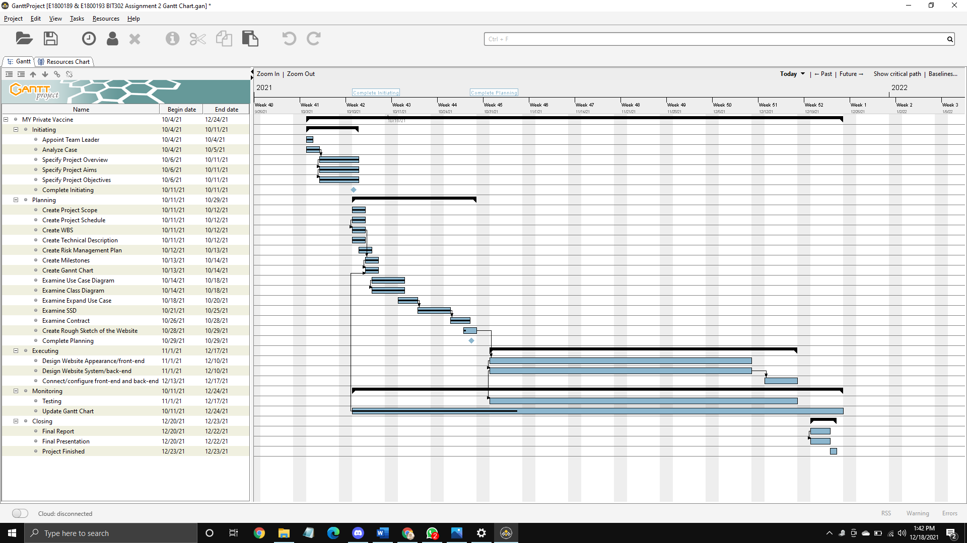

* After

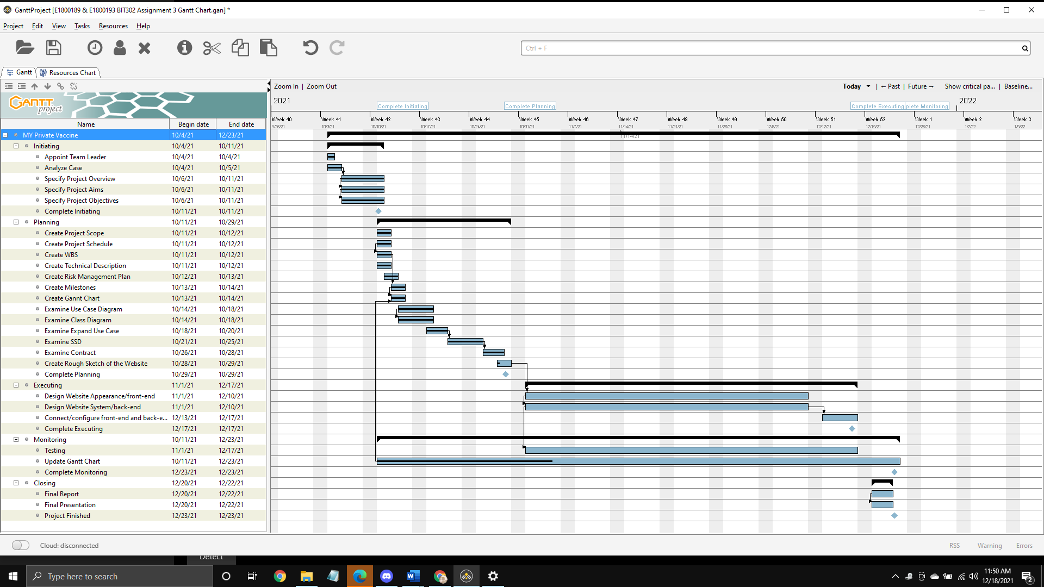

## **Git Hub**

Git Hub link: <https://github.com/zaraathifa/MY-Private-Vaccine.git>

* Git Hub Main Page

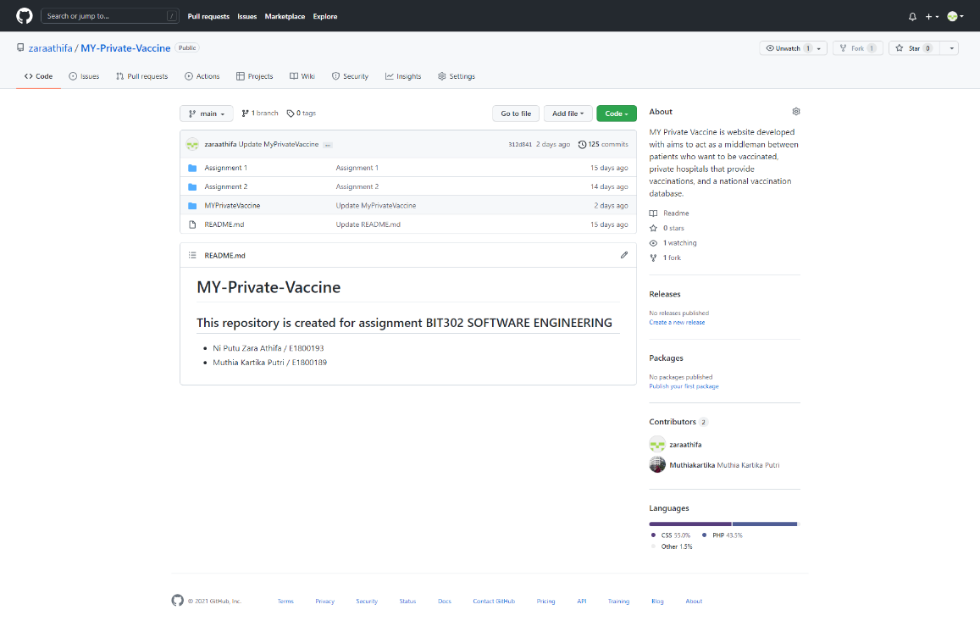

* Git Hub Commit History

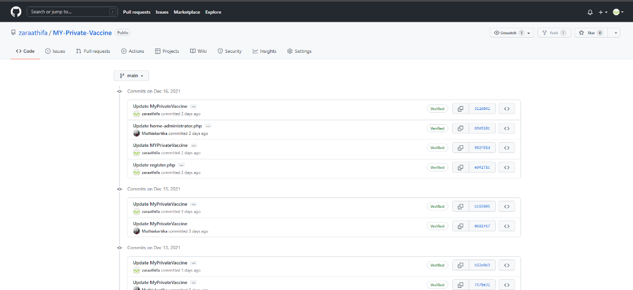

* Git Hub Contributor Insight

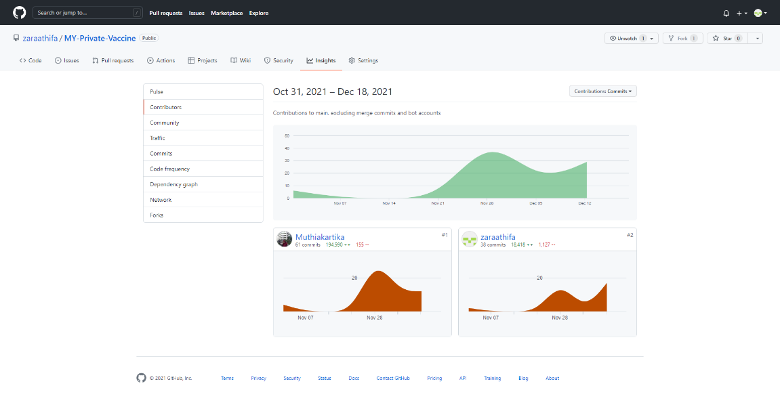

## **Review**

**Student Name & ID: Ni Putu Zara Athifa Wijana & E1800193**

1. **Did the group meet the objectives defined in Assignment 1?**

We believe that we were successful in achieving the goals set out at the start of the project. We established three goals at the start of the project: to assist private health care providers in recording and monitoring the number of patients who will be vaccinated, to assist private health care providers in submitting patient data on vaccine recipients to the national vaccine committee database, and to assist the general public in self-vaccination. We feel that our system is capable of achieving the three mentioned goals.

1. **What went wrong and what went right?**

First and foremost, what went well was that we were able to meet the project's objectives also the requirements and that we were able to complete this project on time without encountering any obstacles that could not be resolved. As for what went wrong, there was nothing that went wrong with the final project result because, as previously stated, we did meet the stated objectives; however, there was something that made us overwhelmed during project work: on the one hand, we had to run the project according to schedule, but on the other hand, we had to work on some tasks outside of this project that had the same short completion time. But, thankfully, we made it through all of this safely.

1. **What you would have done differently?**

What I would’ve done differently if I have multiple tasks to accomplish with short deadlines is that I will try to analyze the complexity of each task first and prioritize the tasks that must be performed first. Furthermore, if I am assigned to a team project in the future or given another opportunity to lead a project, I will continue to grow myself to be a better team member or leader.

**Student Name & ID: Muthia Kartika Putri & E1800189**

1. **Did the group meet the objectives defined in Assignment 1?**

Yes, it did. After completing all of the tasks in this project, we have finally achieved all of the objectives that we set out in assignment 1. We successfully developed a system that can be used by all private healthcare centers that have been registered as COVID-19 vaccination service centers to organize vaccination data such as the number of vaccines available and the number of patients who have received vaccinations. This information will be sent to a national database. This system can also be used by any society that wishes to receive COVID-19 vaccination from a private hospital and a vaccine manufacturer of their choice.

1. **What went wrong and what went right?**

What went right?

All of the team members have already met all of the requirements needed to complete this project. We effectively managed and produced all of the features based on user requests, and this website application is performing as planned and is being well maintained by each team member within the estimated time frame that was set when the project was originally started.

What went wrong?

We are having difficulty managing the time for this project due to the timing constraints in developing it. Furthermore, we have other tasks from another project to complete in a quite short period.

1. What you would have done differently?

During developing this project, I learned a lot as a team member. After all that happened throughout this assignment, I was able to improve my communication skills, collaborate with others, manage my time, and so on. Working on this project has gained a better personality and set of behaviors. In working with other people on another project, I will become more active, communicative, and innovative.

**Conclusion**

We worked on this project in accordance with the requirements and objectives set forth at the early stage of the project. We realized that there are various things we can gain while working on this project that will help us better. We will work even harder in the future to improve our time management skill, as it turns out to be a challenging issue that we face when working on this project.  We will continue to improve our skill and abilities so that we can give a closer-to-perfect end result.

# References

Ian, S. (2015). *Software Engineering Global Edition* (10th ed.). PEARSON EDUCACION.